Table of Contents

Problem statement 5

Objective 5

Scope 5

Target audience 5

Existing system that are in use 5

Project Duration 6

Algorithm 7

Flowchart for the system 7

Updated flowchart design 9

ERD 10

EERD 10

UML use case 11

Technology to implement on the system 12

Technology 12

IDE to build system 12

Interface design 13

Updated interface design 15

Storyboard 17

Interface 18

Main page 18

Course page 18

Session time selection 18

Fill in form 19

Confirmation popup 19

Summary page 19

SQL 20

Table course 20

Table session 21

Feedback on the system 22

Version 2.0 alpha 22

Interface version 2.0 alpha 22

Main page 22

Register page 23

Login page 23

Logged in front page 23

Course page 24

Time session for subject 24

Summary page 25

Session history check 25

Page code 26

Heading.jsp 26

Index.jsp 26

Login.jsp 27

Register.jsp 27

Course.jsp 28

Timesession.jsp 28

Summary.jsp 29

Sessionhistory.jsp 29

ERD for version 2.0 alpha 30

UML use case 31

Initial design for v2.0a 31

Real system use case 31

SQL 32

Class_session table 32

Users table 32

Course table 33

Session_record table 34

SQL Procedures 34

Find_user_record 34

This_year_session procedure 35

Test plan 36

Image evidence 36

Image 101 36

Image 102 36

Library integrated in the system 37

Update version 3.0 alpha version 38

UML Use Case version 3.0 38

ERD version 3.0 39

Flowchart 40

User flowchart 40

Register course 41

Check session history flowchart 42

Profile page 43

Admin page 44

SQL version 3.0 45

Class_session table 45

Users table 45

Course table 46

Session_record table 47

SQL Procedures 47

Find_user_record 47

This_year_session procedure 48

Insert_class_session 49

Check_else_insert_course 49

Webpage interface version 3.0 50

Main menu 50

Login 50

Register 51

Main page for user 51

Main page for admin 51

Admin page import spreadsheet 52

Import successful page after spreadsheet is uploaded 52

Wrong file content 52

Course selection page 53

Select time session page 53

Summary page 53

Email page 54

Session history page 54

Edit profile page 55

Change profile 55

Source code 3.0 56

Heading.jsp 56

Index.jsp 56

Login.jsp 57

Register.jsp 57

Import.jsp 58

Form.jsp 58

Editprofile.jsp 59

Timesession.jsp 59

Summary.jsp 60

Sessionhistory.jsp 60

Course.jsp 61

Library integrated in the system 3.0 62

Justify decisions made how the system will result in an effective solution. 63

Future planning for the system 65

# Problem statement

The training department produce a spreadsheet which lists the courses they run each month.

# Objective

A spreadsheet that contains data will be include into the database.

Allow users to select the training sessions they wish to attend on a form based on a spreadsheet.

The responses the user makes on the form will then create a summary document listing selections made which is emailed to the user.

# Scope

The user for this system will be employee of the company, supervisor of the company training department and the superior management.

# Target audience

This system will be targeted to the employee of training department of the company.

# Existing system that are in use

1. Spreadsheet system to provide monthly courses to employee to attend.
2. Employee required to fill the form and submit to the associated supervisor or the management team.
3. The system will help to digitalise the whole process.

# Project Duration

|  |  |  |  |  |  |
| --- | --- | --- | --- | --- | --- |
| Phase | No | Activity | Week 1 | Week 2 | Week 3 |
| Phase 1 | 1 | Gathering requirements and information of the training department |  |  |  |
| 2 | Identify the problem |  |  |  |
| 3 | Estimate project duration |  |  |  |
| Phase 2 | 1 | Prepare algorithm for project development |  |  |  |
| 2 | Provide interface design |  |  |  |
| 3 | Update and changes |  |  |  |
| Phase 3 | 1 | Implement solution |  |  |  |
|  |  |  |
|  |  |  |
| Phase 4 | 1 | Test plan |  |  |  |
| 2 | Optimise and update |  |  |  |
| Phase 5 | 1 | Writing report |  |  |  |
| Phase 6 | 1 | Show products |  |  |  |
|  |  |  |  |  |  |
|  |  |  |  |  |  |

# Algorithm

## Flowchart for the system

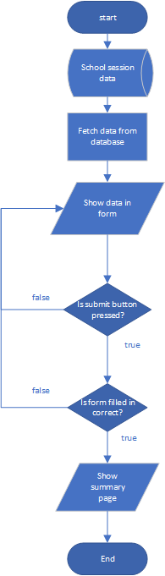

I show this flowchart to my friend, I received feedback and made an improvement to my flowchart.

Flowchart above contain some problem as the subject time is not consistent every time. This might be harder for development. It is better to show the subject first, then the session time for it. At last page is a form before summary, the date and time for the subject in the month will be shown.

## Updated flowchart design

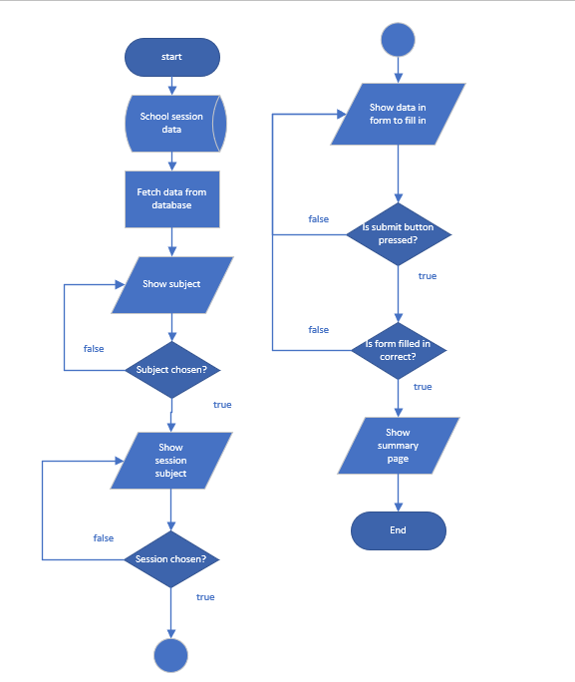

# ERD

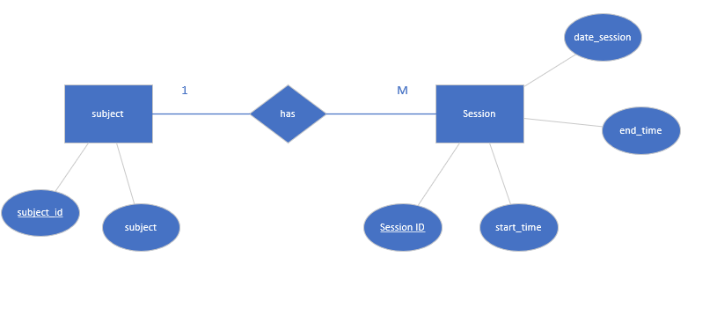

1 subject can have many sessions. 1 session can only have 1 subject.

## EERD

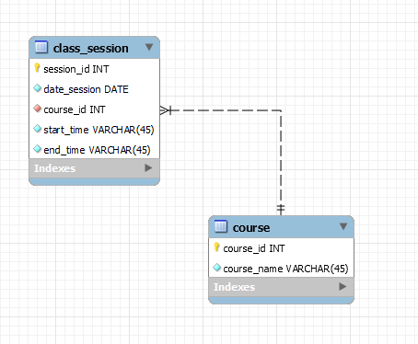

# UML use case

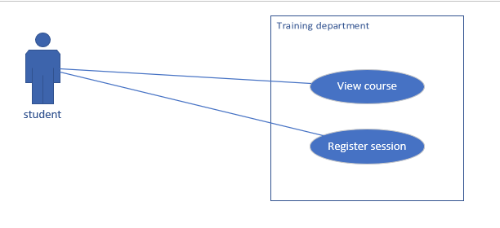

# Technology to implement on the system

## Technology

* Java Programming language
* JSTL
* Servlet
* Javascript
* HTML/JSP
* CSS

## IDE to build system

* Ecplise IDE
* MySQL Workbench
* Visual Studio Code

# Interface design

Summary page

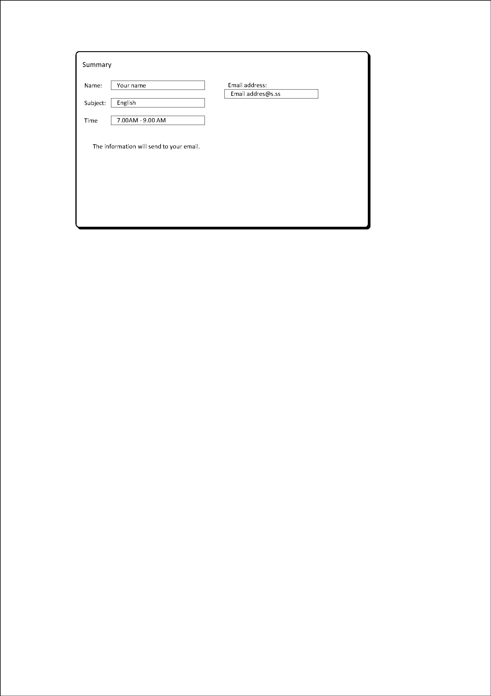

Selection class design 1- login/signup required

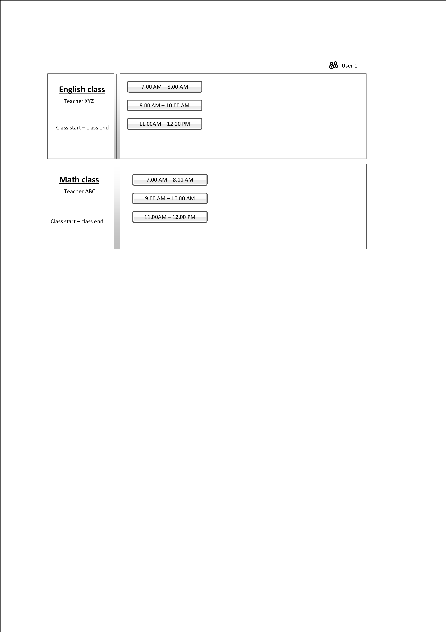

Selection class design 2- login/signup not required (form based)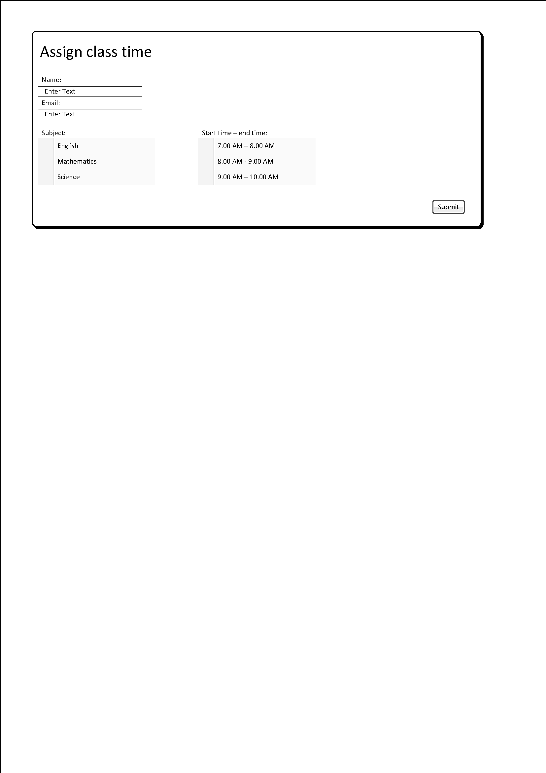

Import page – optional

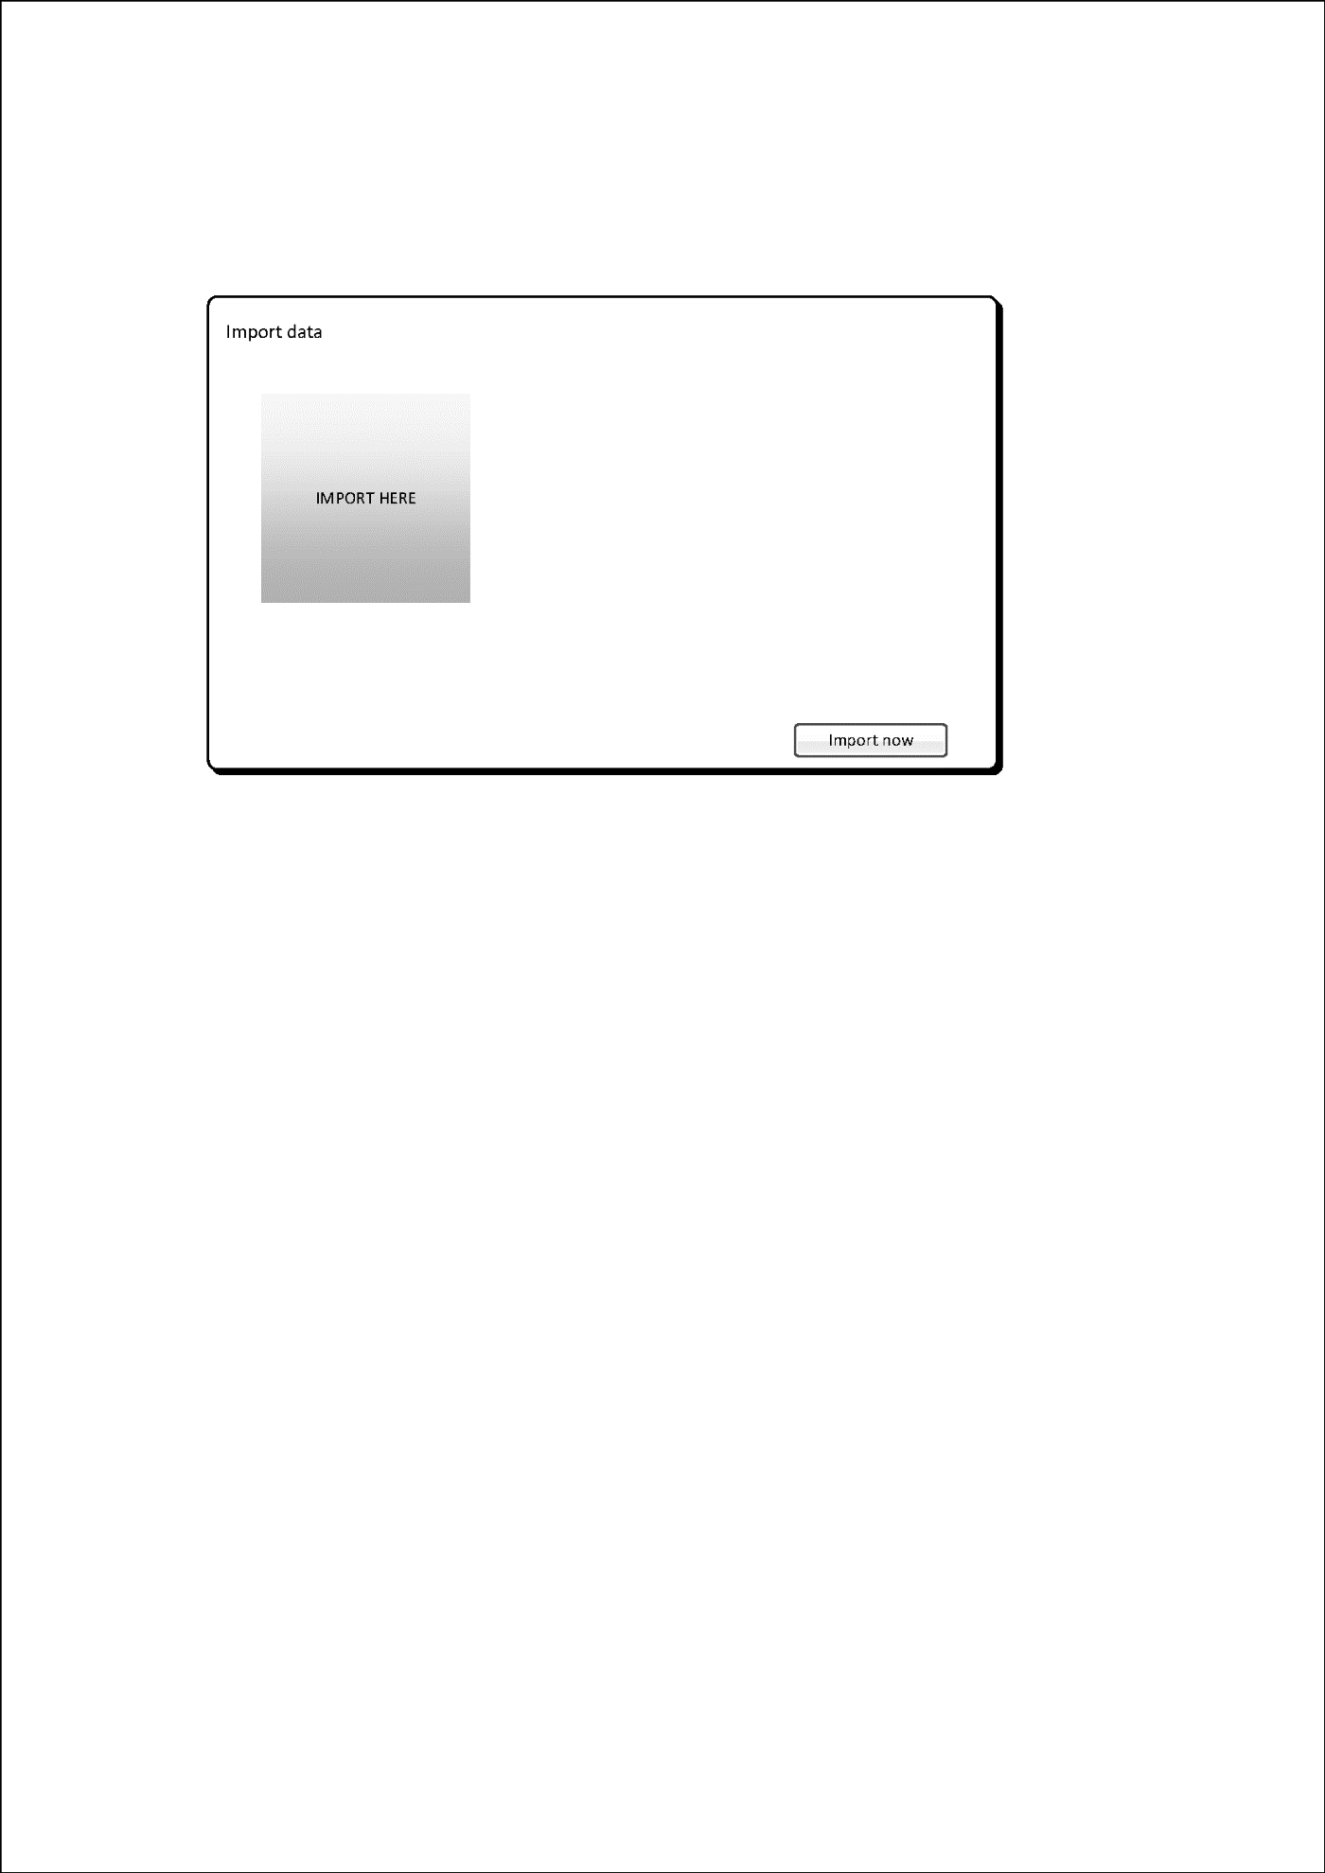

Summary page - design 2



Heading with login/signup - optional

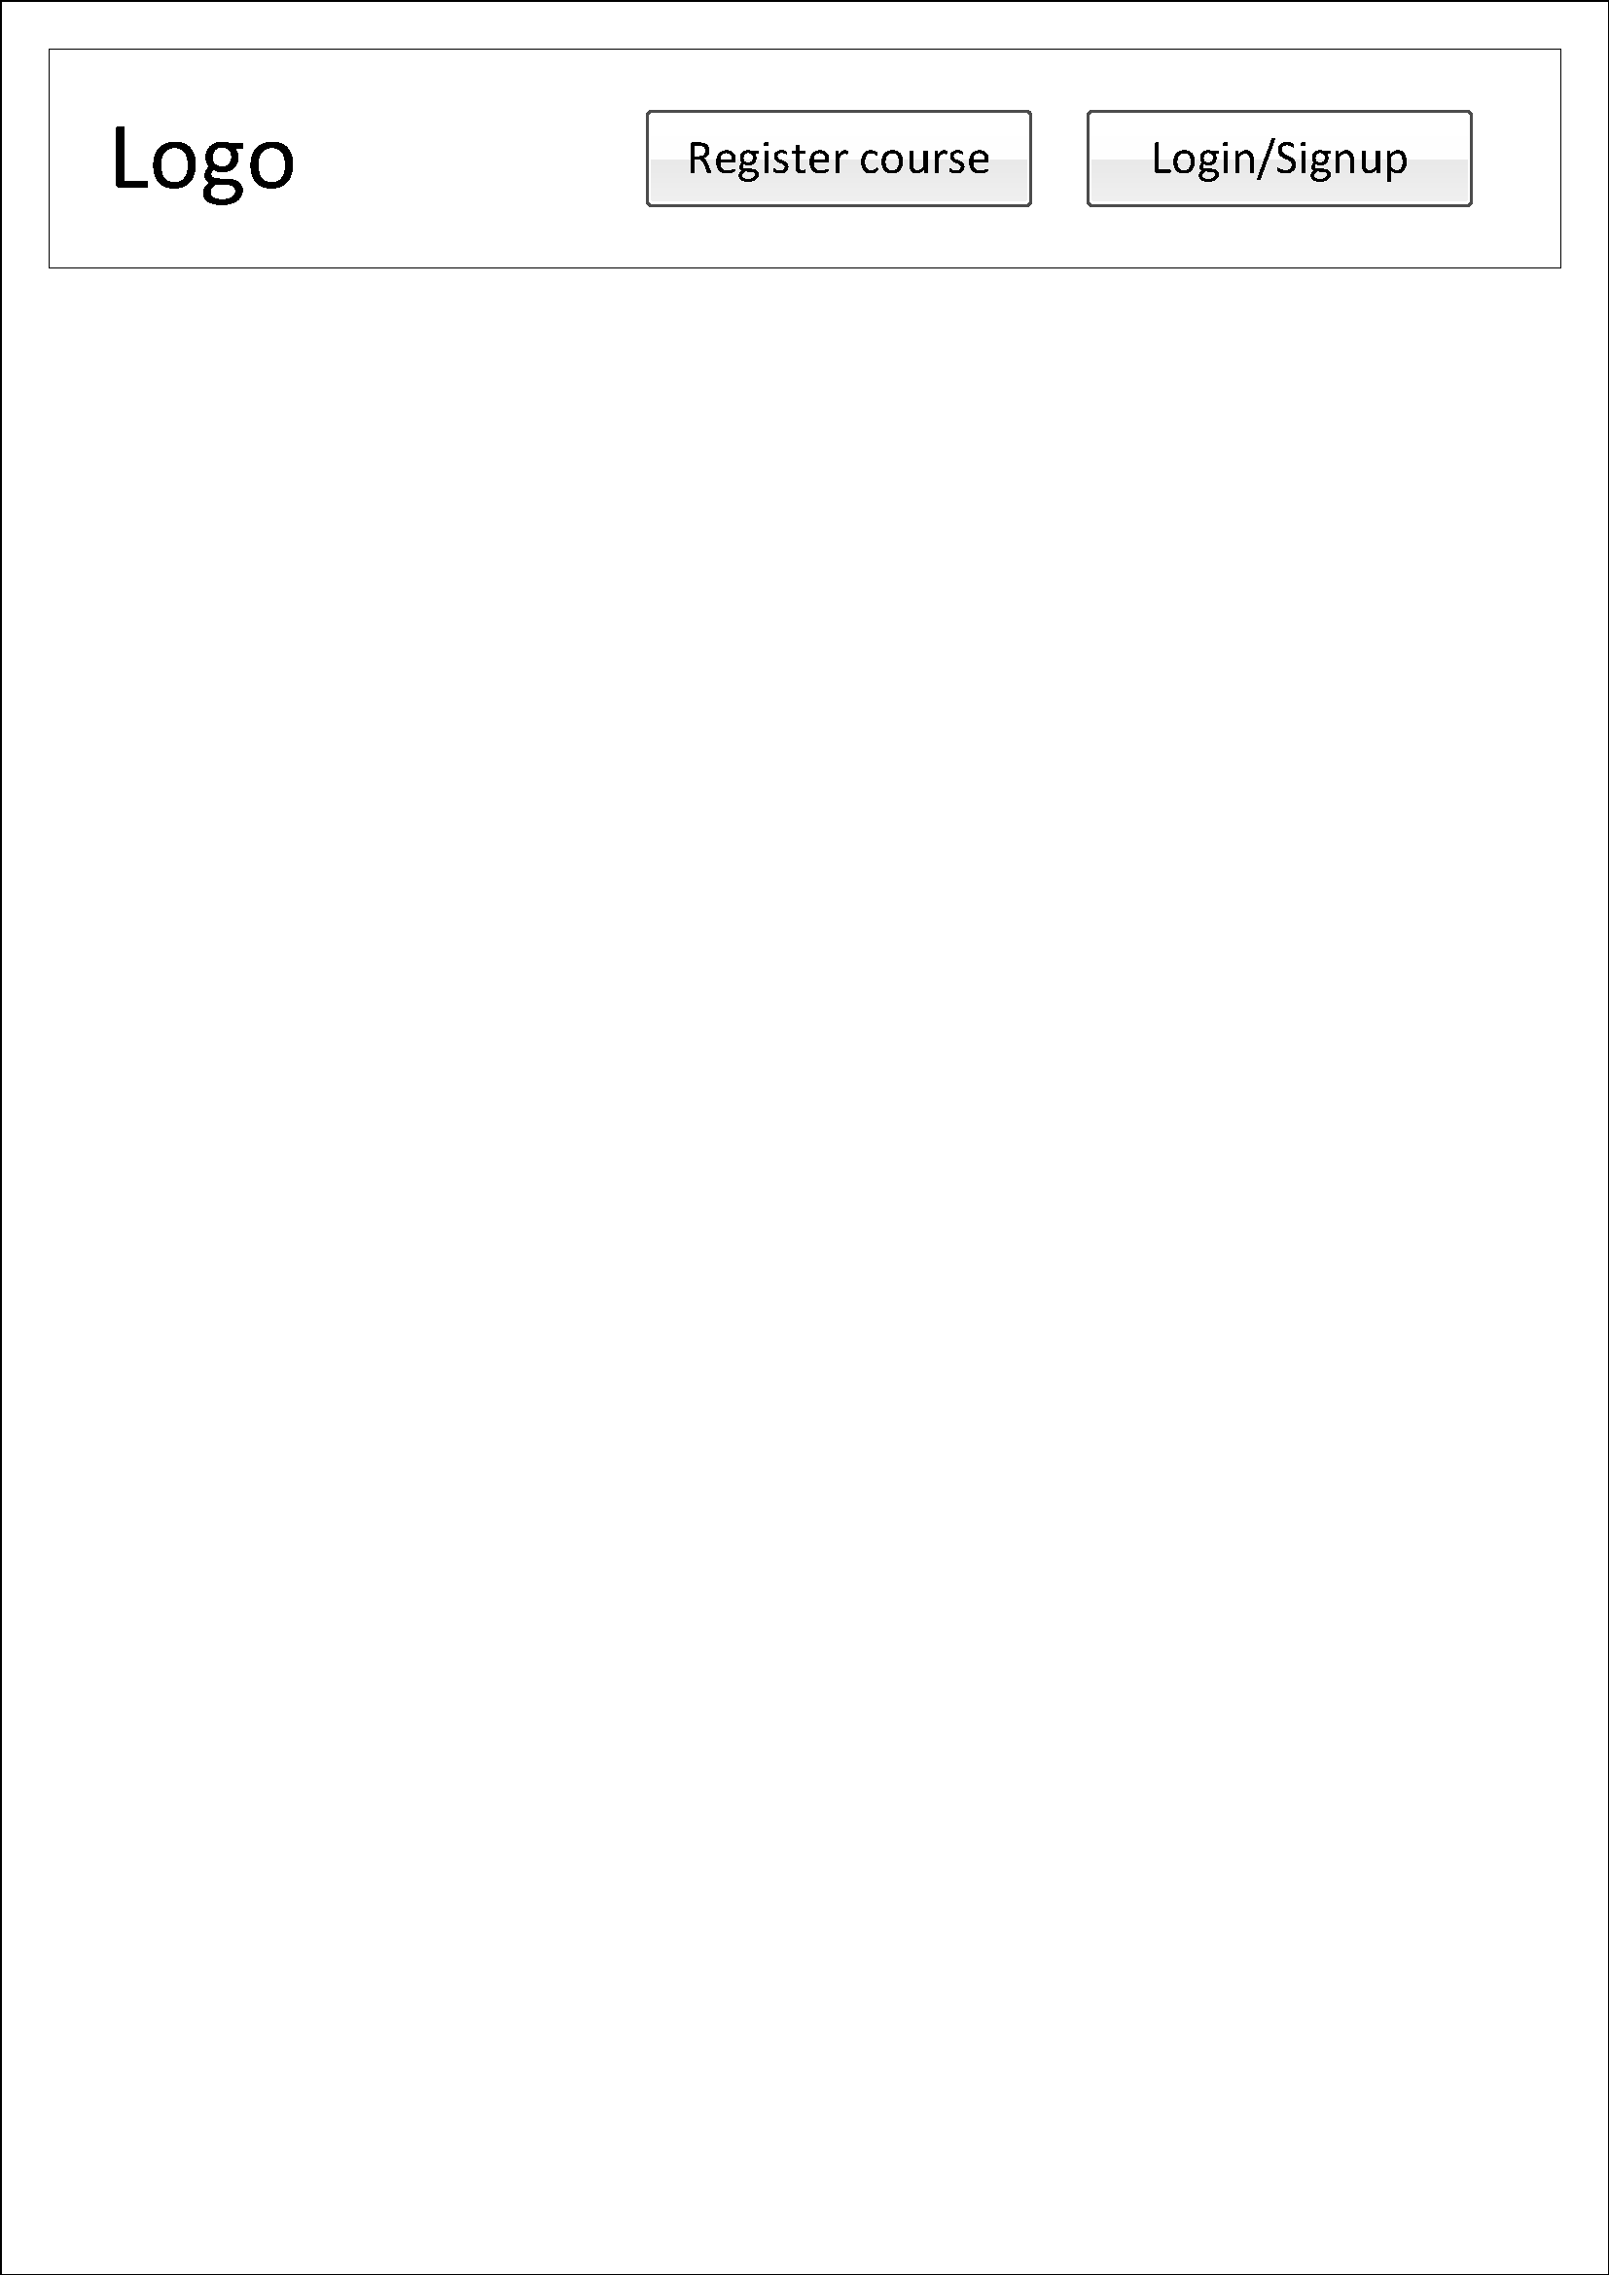

Heading 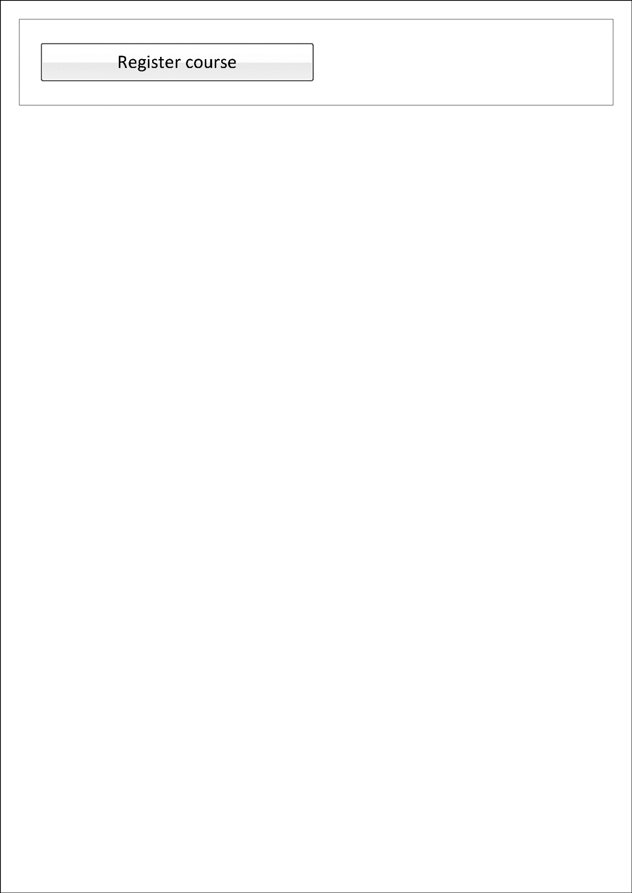

## Updated interface design

Main page

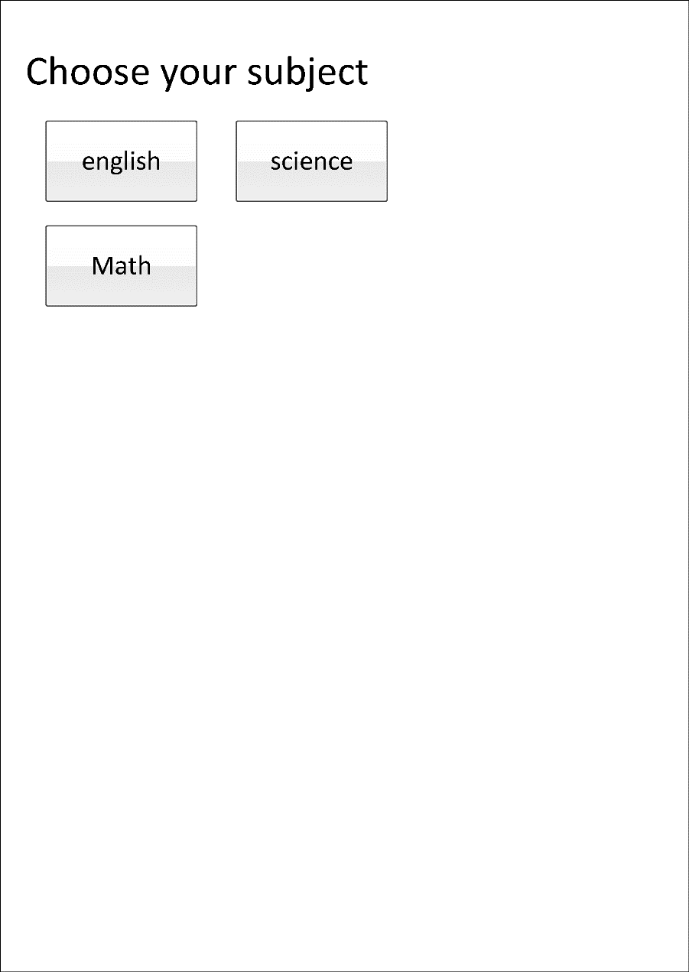

Choose the month to attend the course after selecting the subject

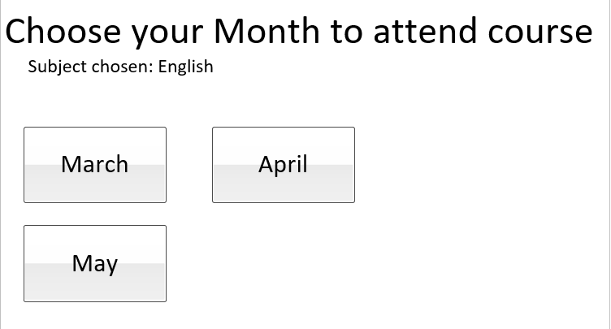

Page after subject selection

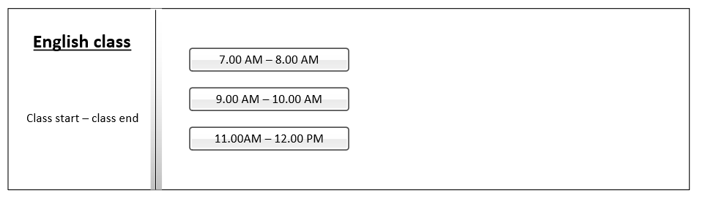

Form page after time selection

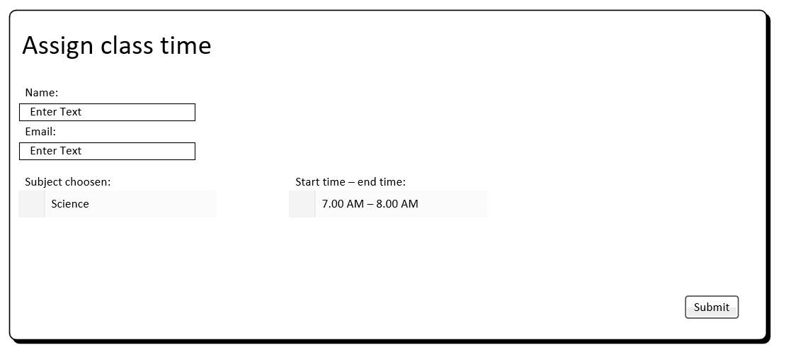

Summary



# Storyboard









# Interface

## Main page

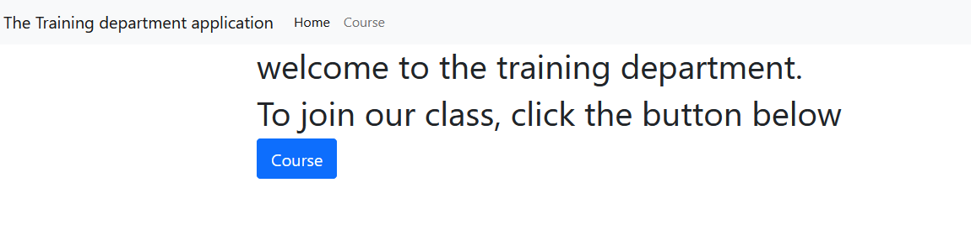

## Course page

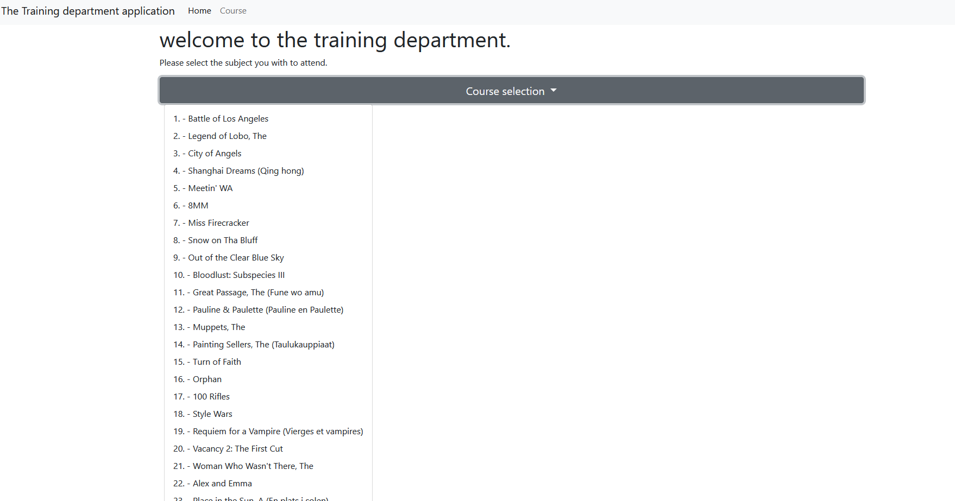

## Session time selection

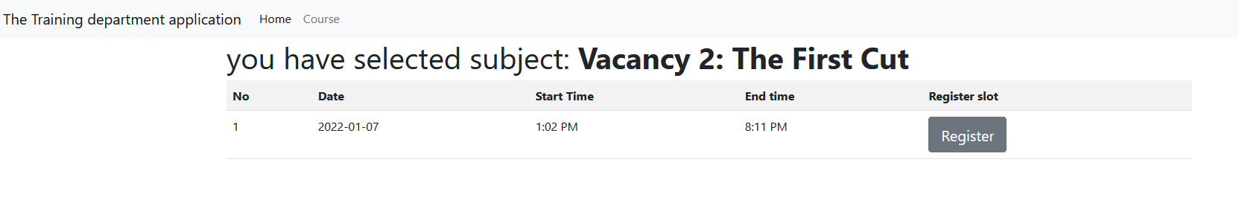

## Fill in form

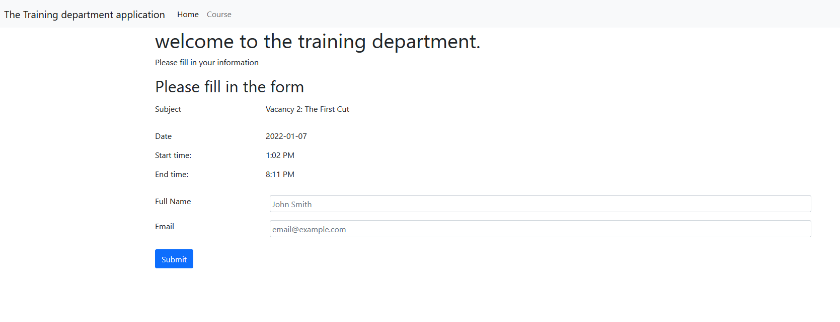

## Confirmation popup

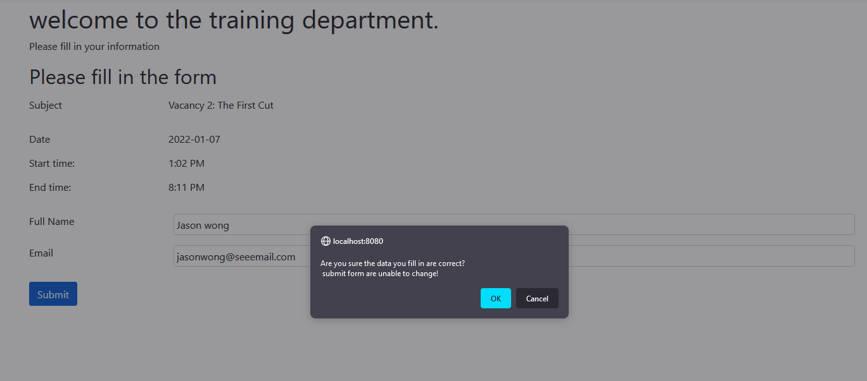

## Summary page

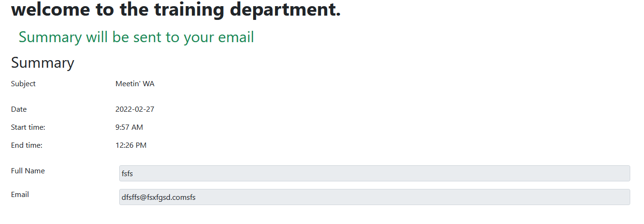

# SQL

Database name: tdp_model

## Table course

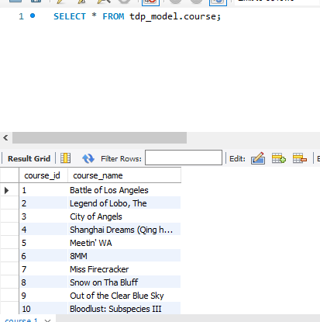

## Table session

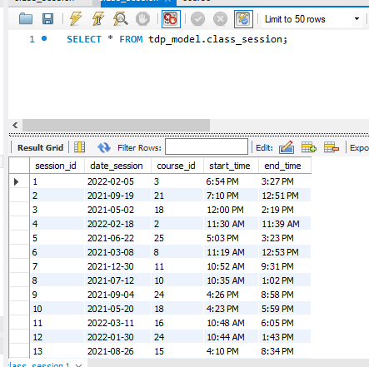

# Feedback on the system

|  |  |
| --- | --- |
| System version | V1.0 Alpha |
| Feedback commenter: | Mentor Myint Haymar Lwin in online classroom meeting |
| Comment: | If time allows, please complete the system. Add login/signup, admin system, history check, create session. |

# Version 2.0 alpha

|  |  |
| --- | --- |
| System version | V2.0 alpha |
| Functions included | Login/signup, create session, history check.  Added teacher teaching session. |
| Functions not included | Admin system, history check, create session, add subject function. Account edit, |
| Reasons not include | No time to work on |

# Interface version 2.0 alpha

## Main page

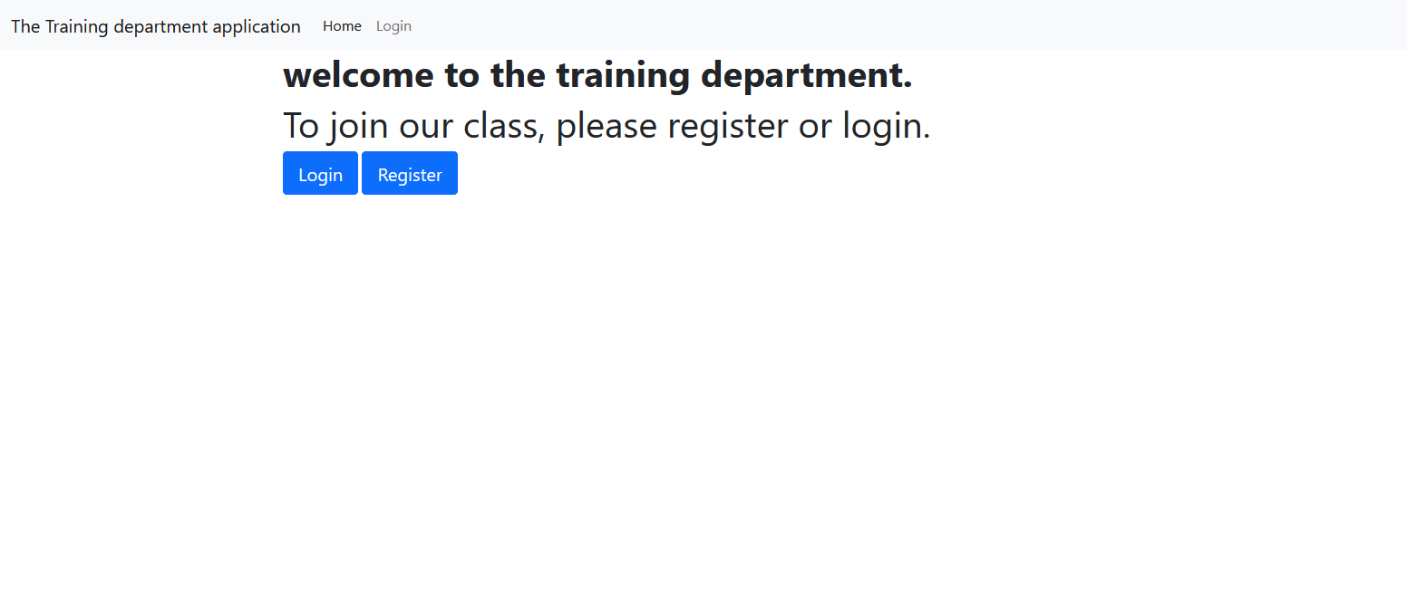

## Register page

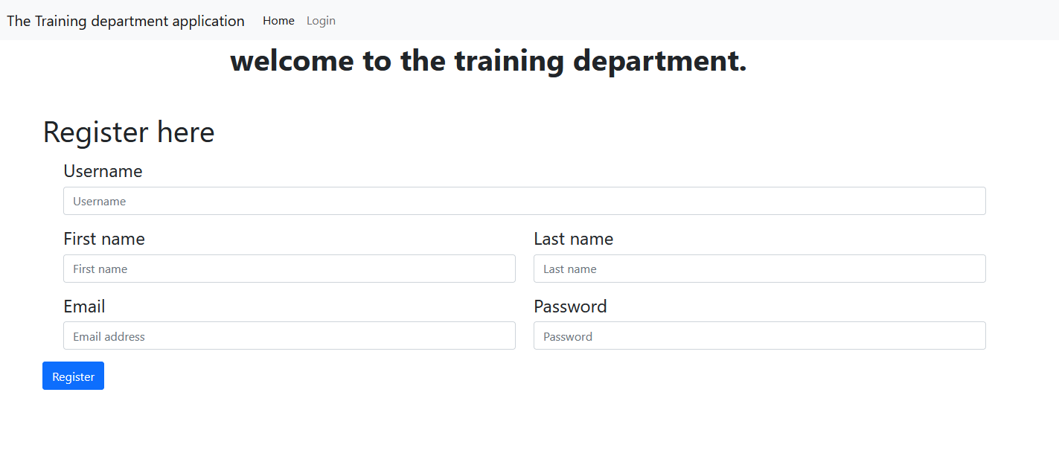

## Login page

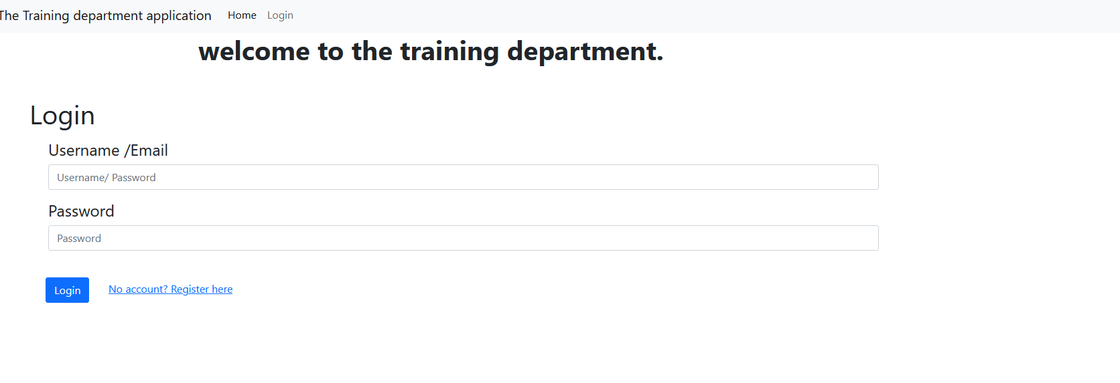

## Logged in front page

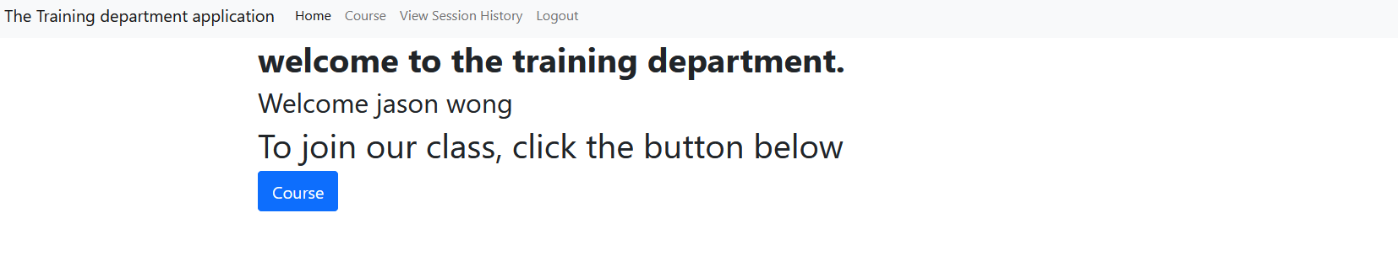

## Course page

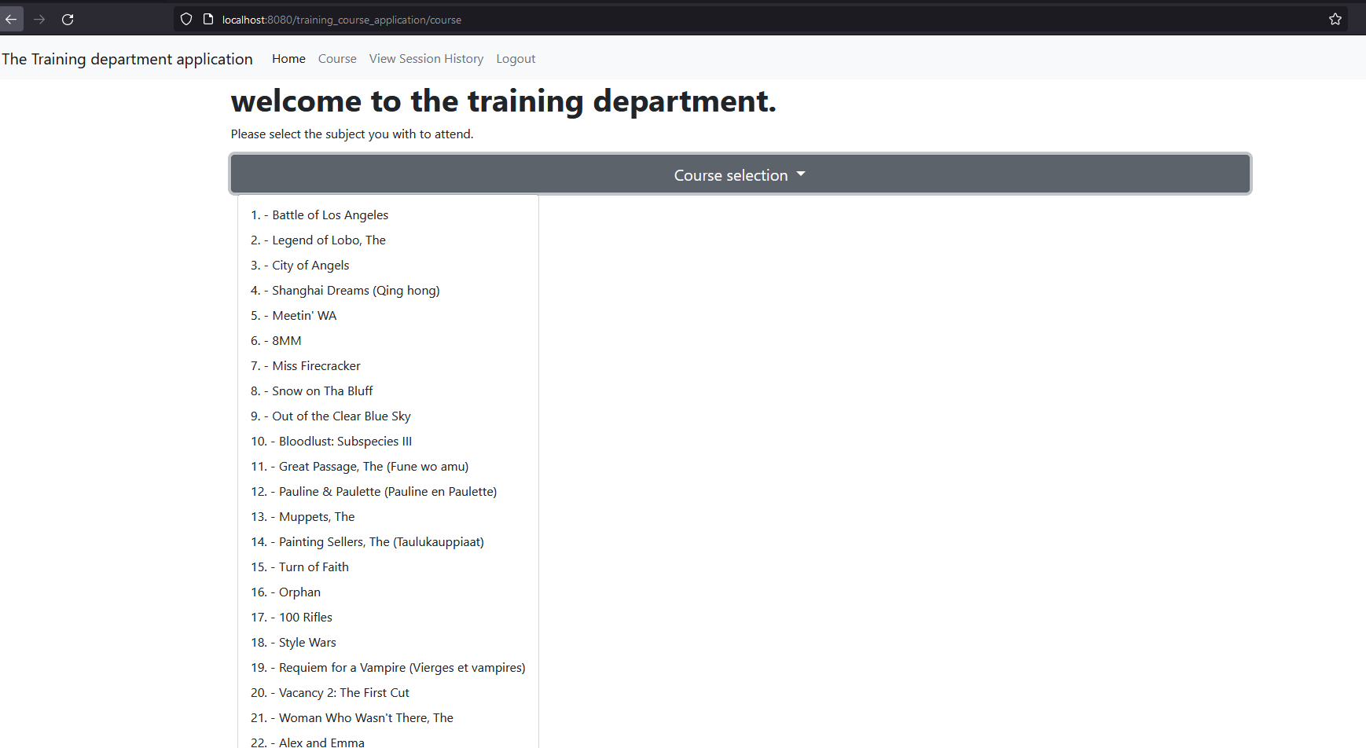

## Time session for subject

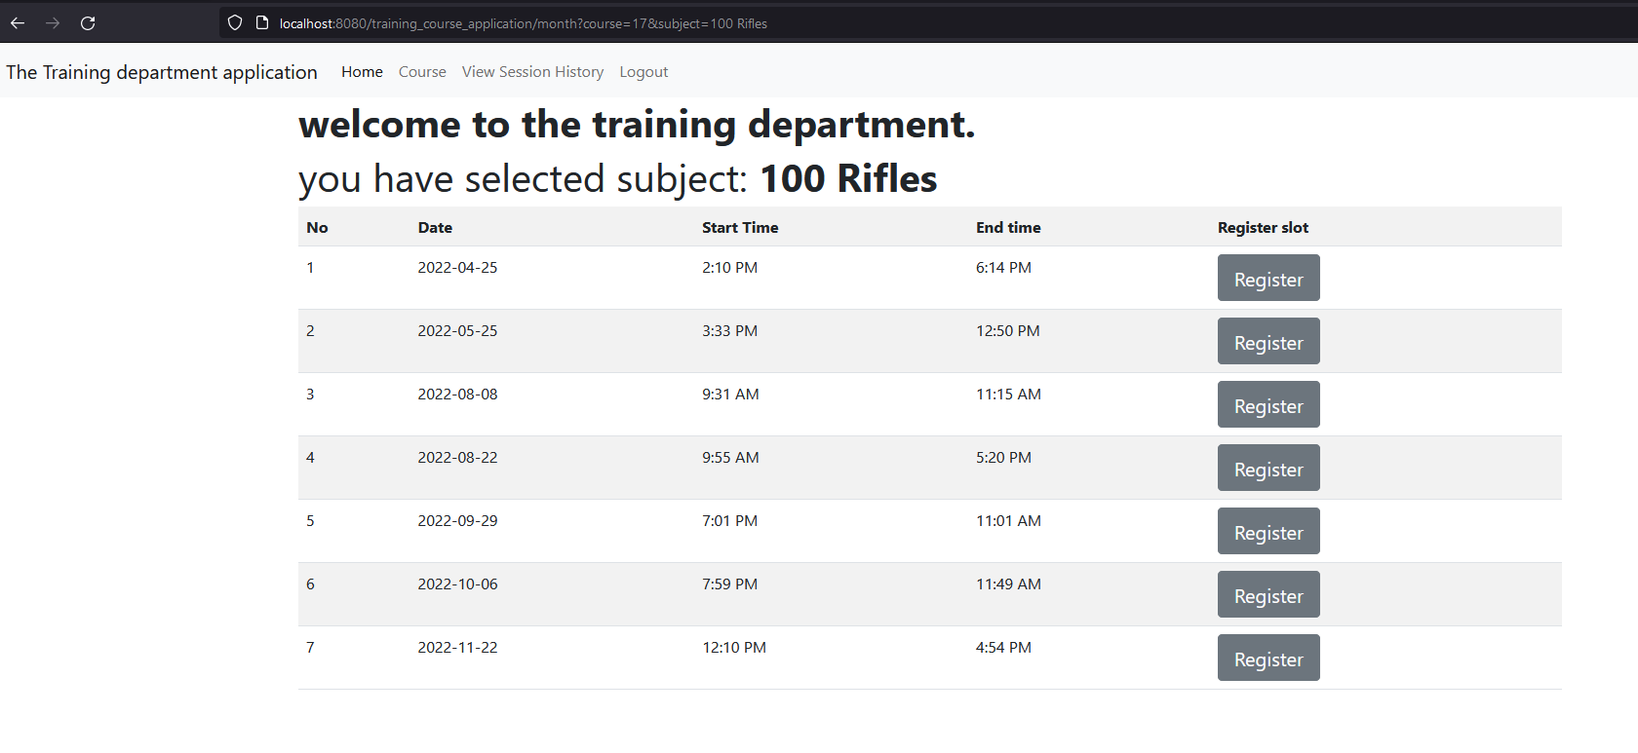

## Summary page

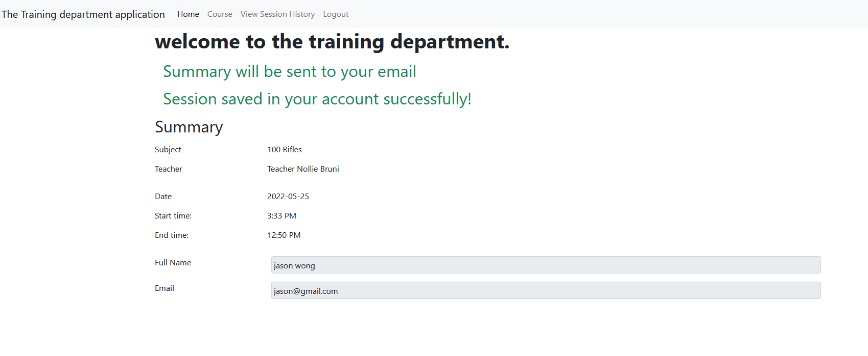

## Session history check

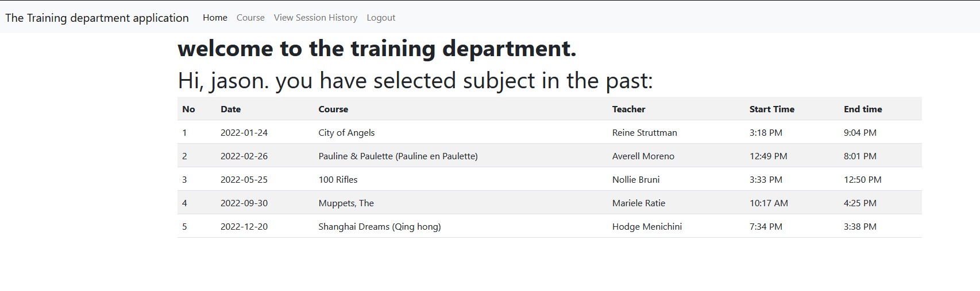

# Page code

## Heading.jsp

­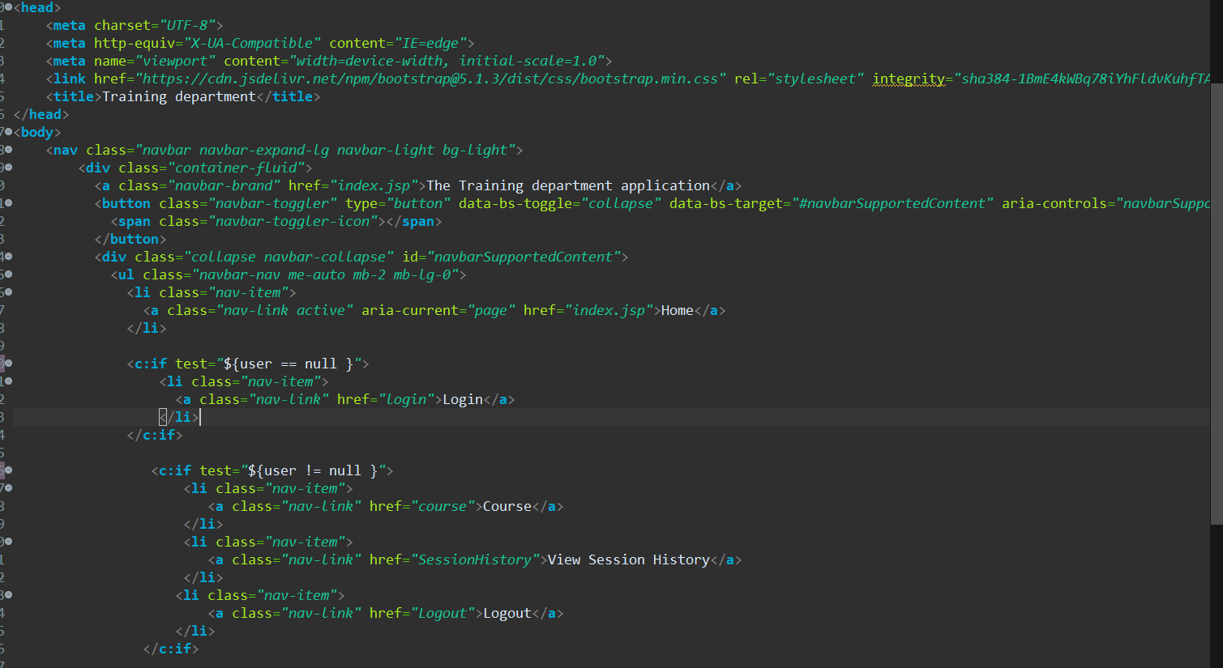

## Index.jsp

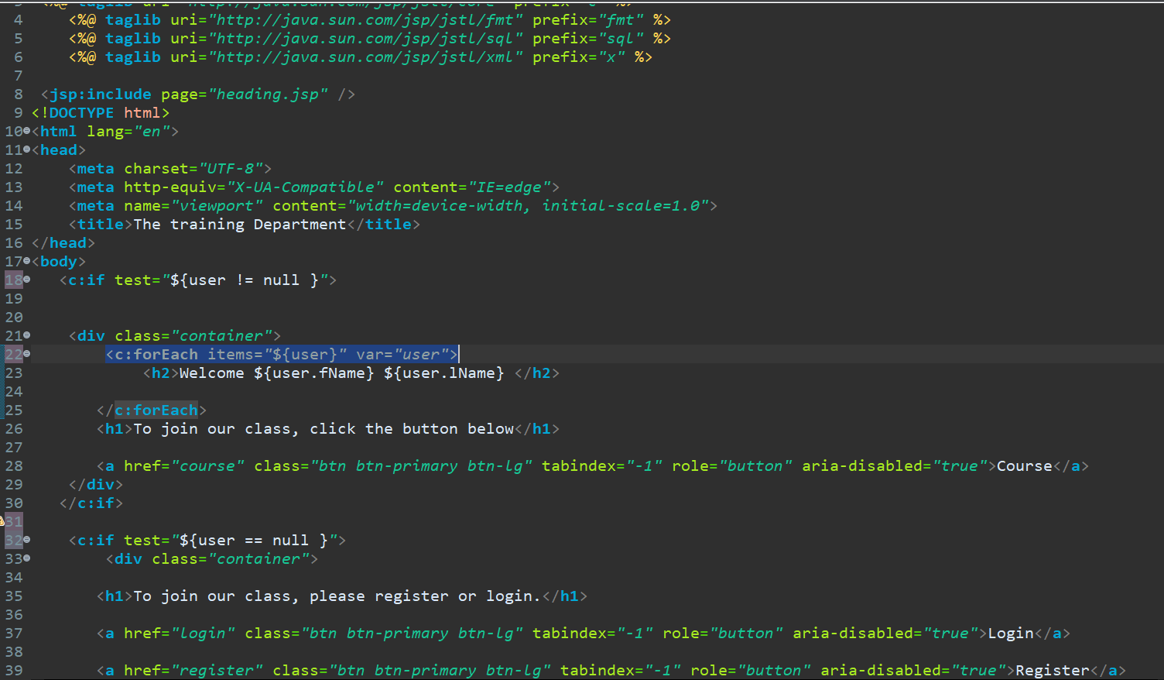

## Login.jsp

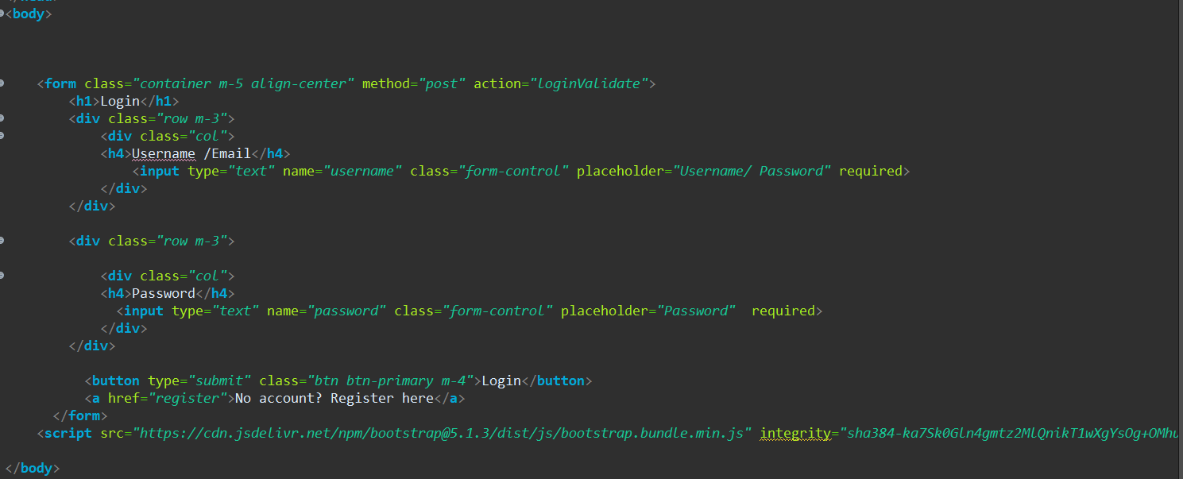

## Register.jsp

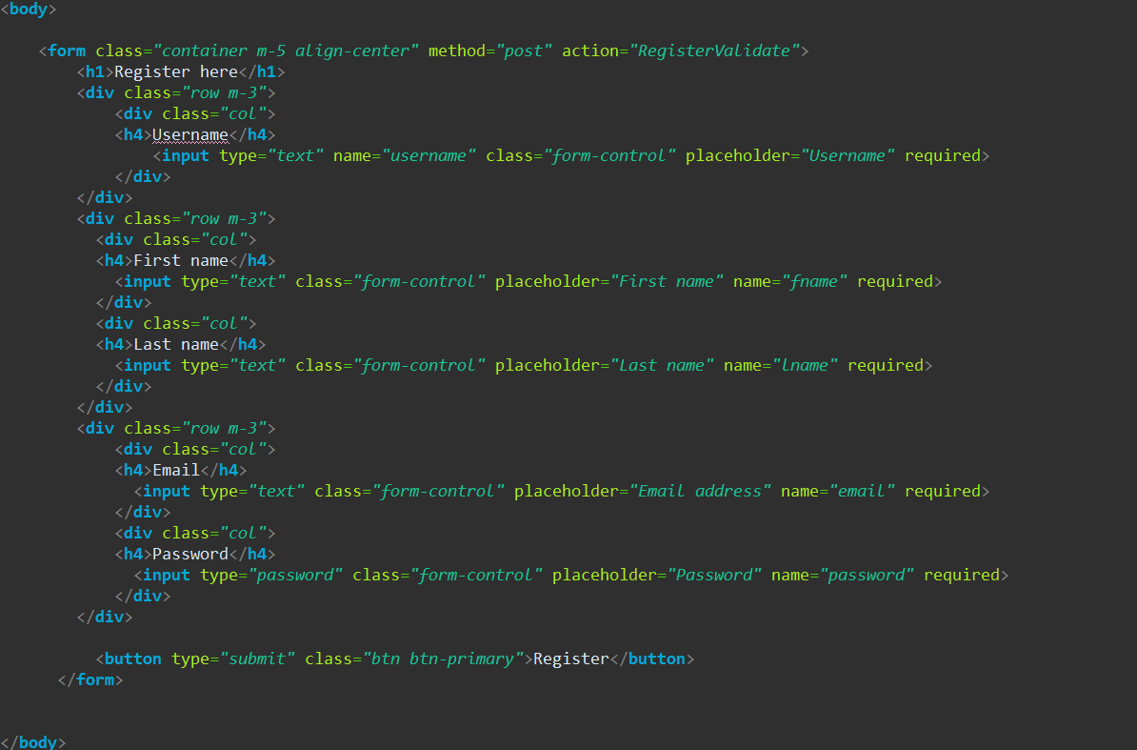

## Course.jsp

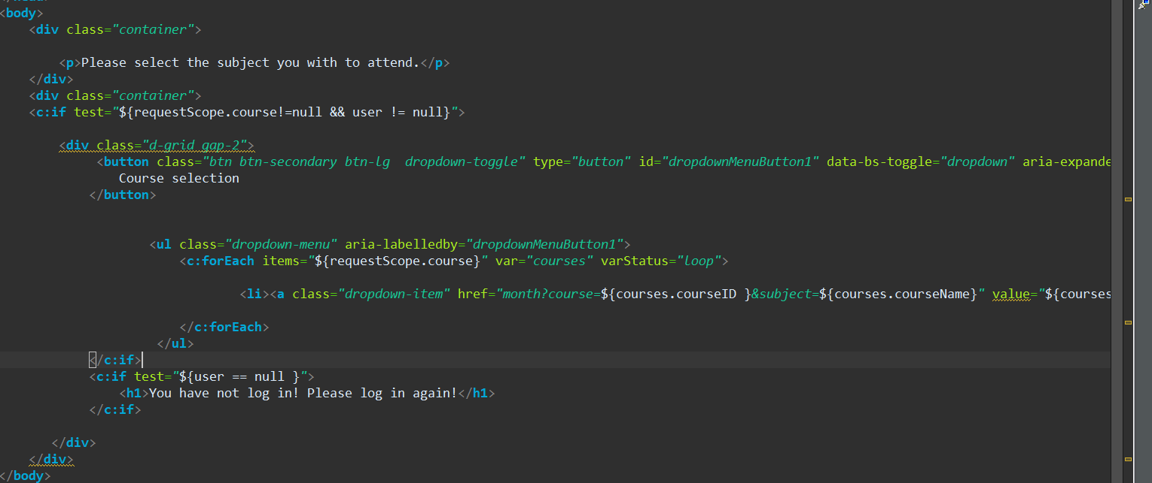

## Timesession.jsp

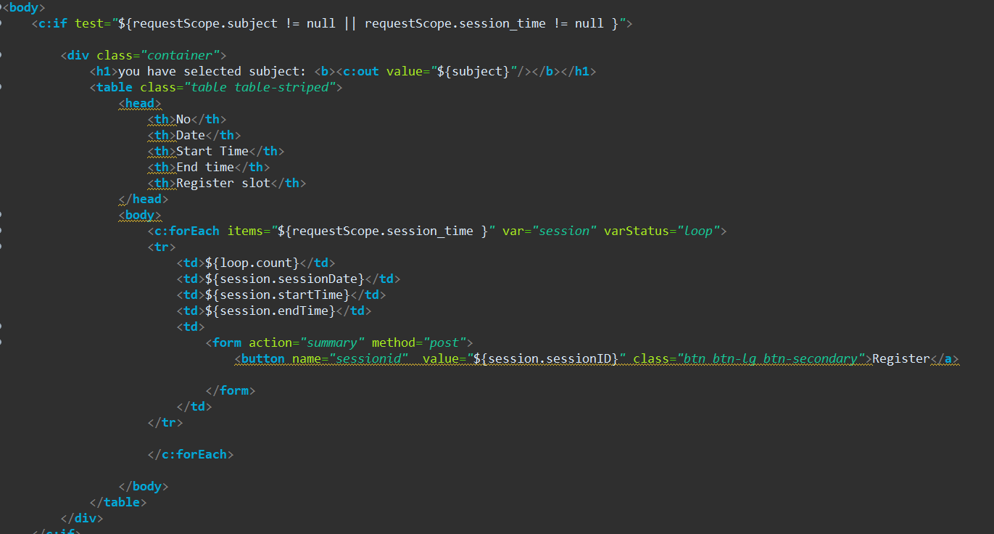

## Summary.jsp

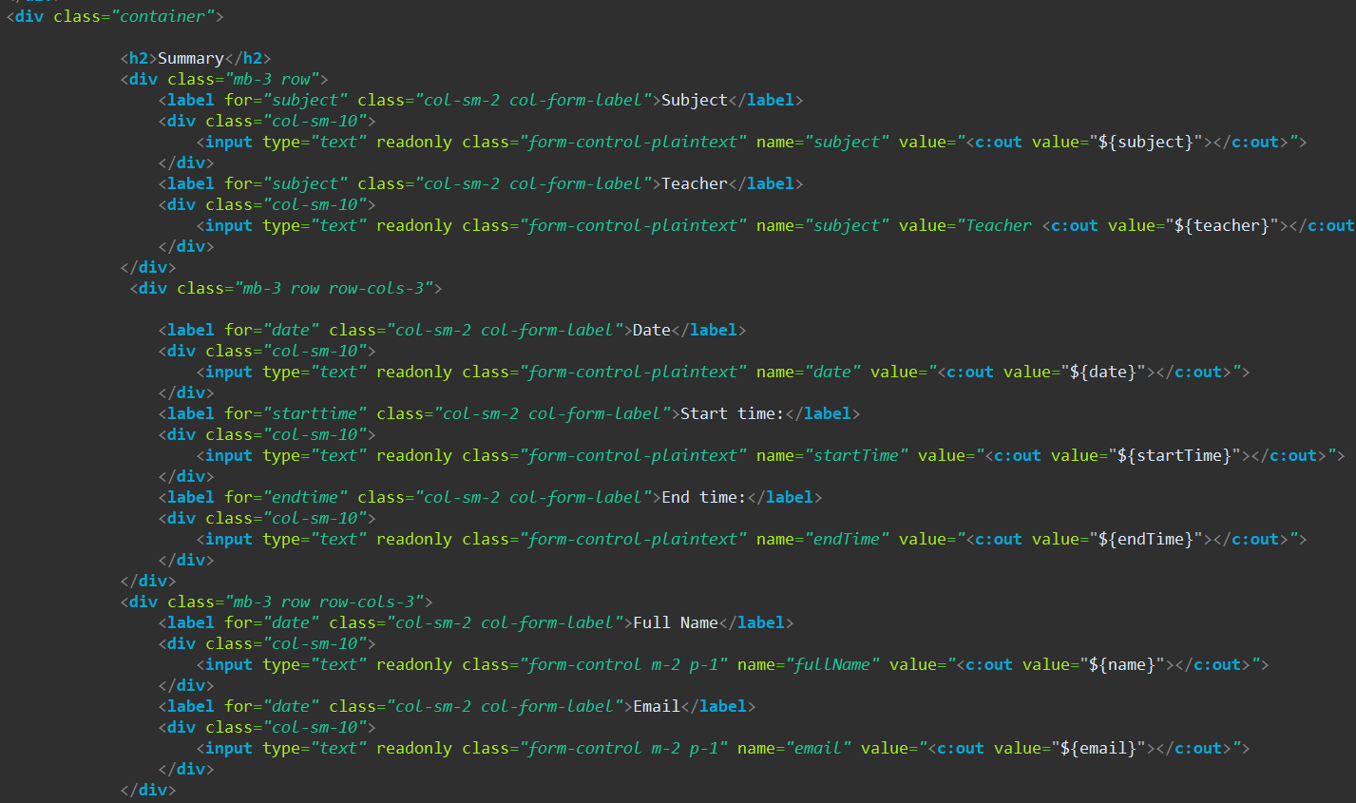

## Sessionhistory.jsp

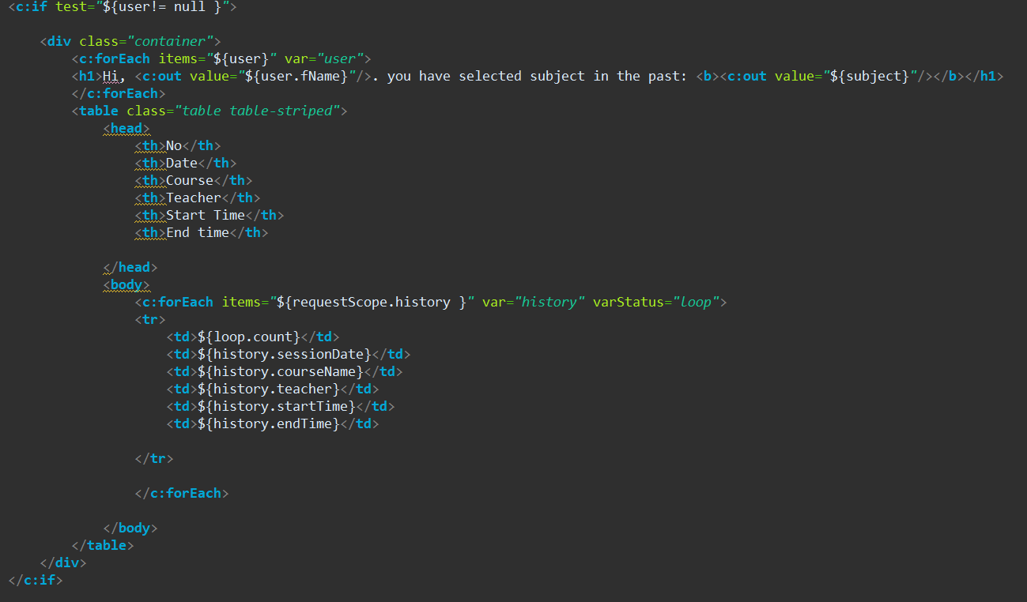

# ERD for version 2.0 alpha

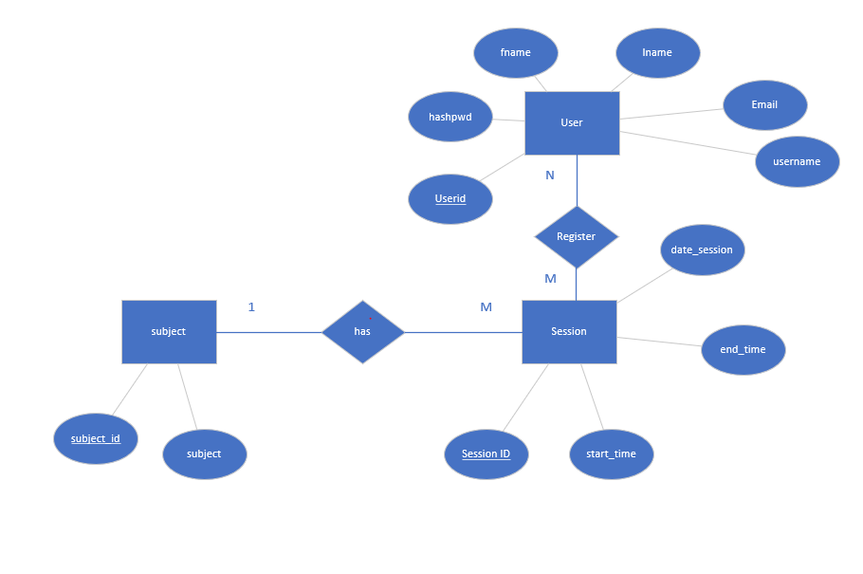

1 subject can have many sessions. One session has 1 subject only. User can register many sessions, many sessions can be registered by many users.

# UML use case

## Initial design for v2.0a

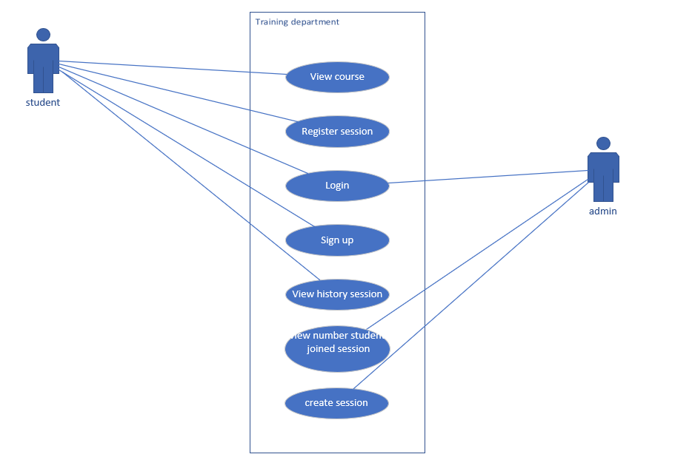

## Real system use case

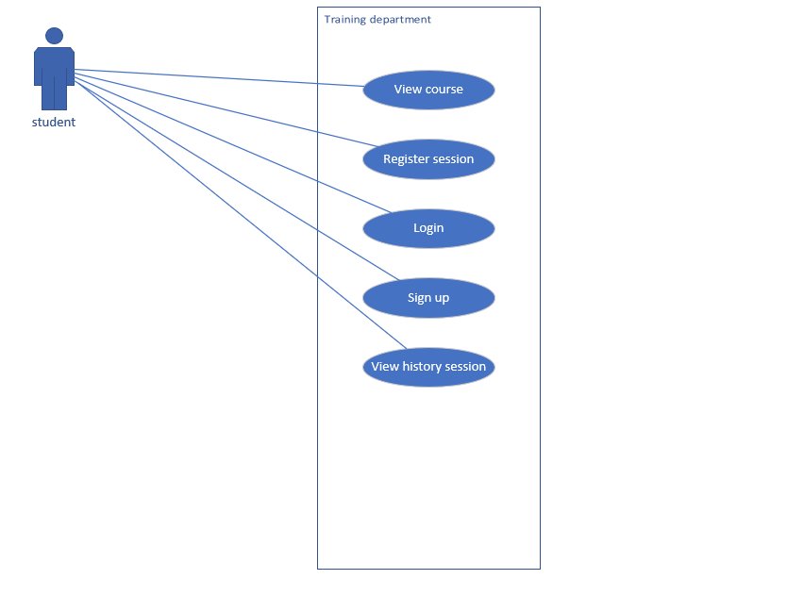

# SQL

Database name: tdp_model

## Class_session table

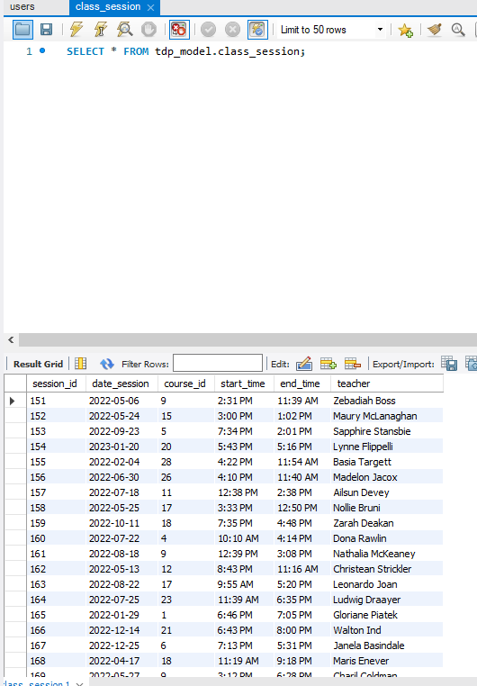

## Users table

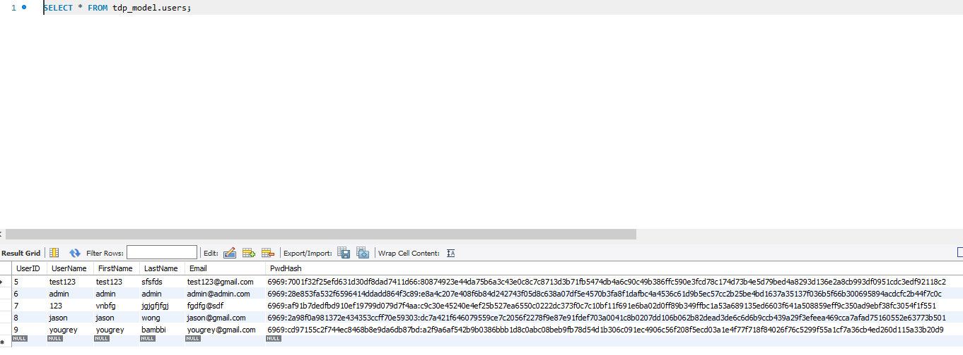

## Course table

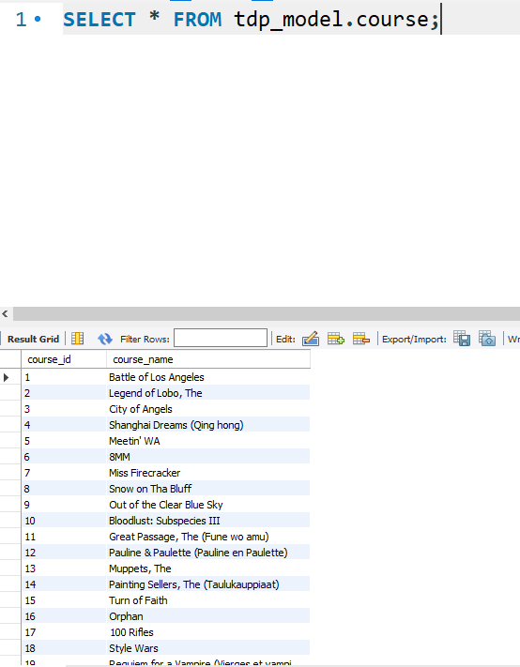

## Session_record table

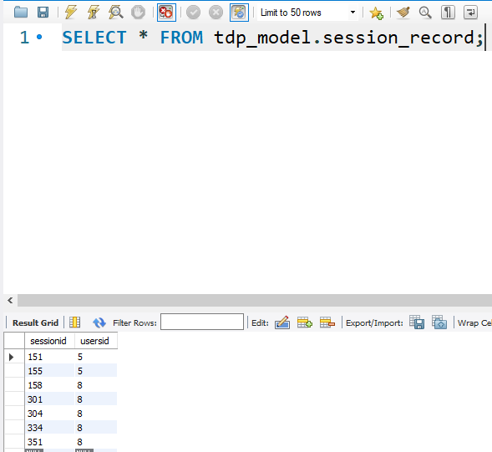

## SQL Procedures

### Find_user_record

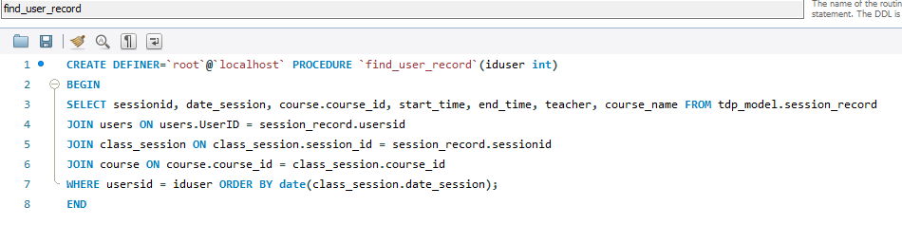

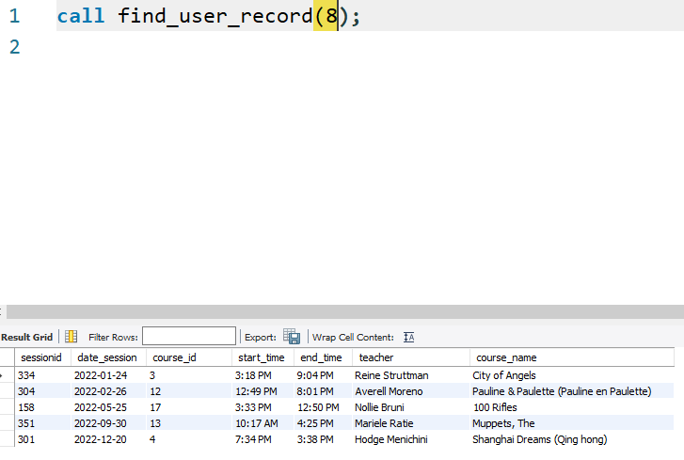

### This_year_session procedure

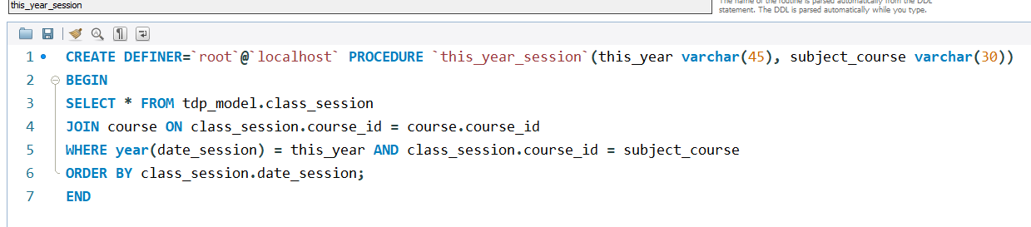

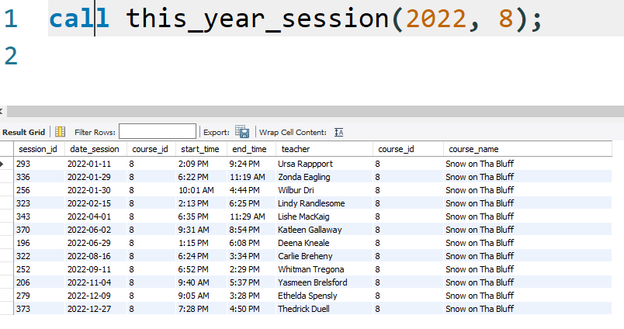

# Test plan

|  |  |  |  |  |
| --- | --- | --- | --- | --- |
| No | Test area | Test expectation | Test result | Status |
| 1 | Interface testing | When user skip login and went to course such as,  System will lock user from accessing it | Refer to Image 101 | success |
| 2 | Acceptance testing | If the user fill in the wrong information when login, system will reject | Refer to Image 102 | success |
|  |  |  |  |  |

## Image evidence

### Image 101

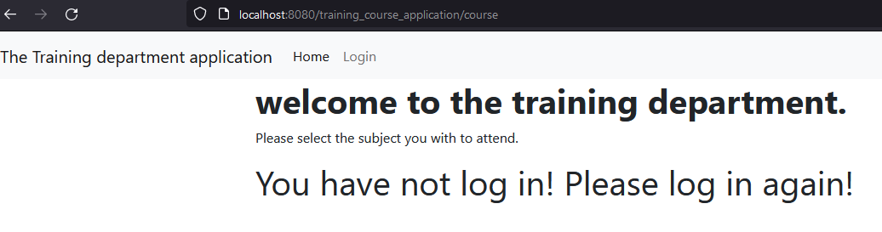

### Image 102

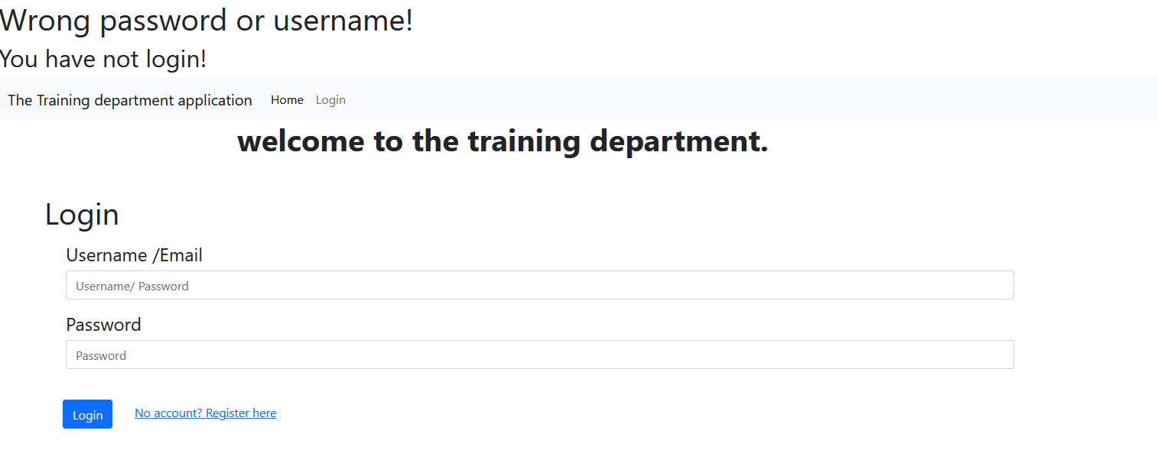

# Library integrated in the system

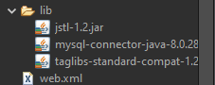

Jstl 1.2.jar

Mysql. JDBC- 8.0.28

# Update version 3.0 alpha version

# UML Use Case version 3.0

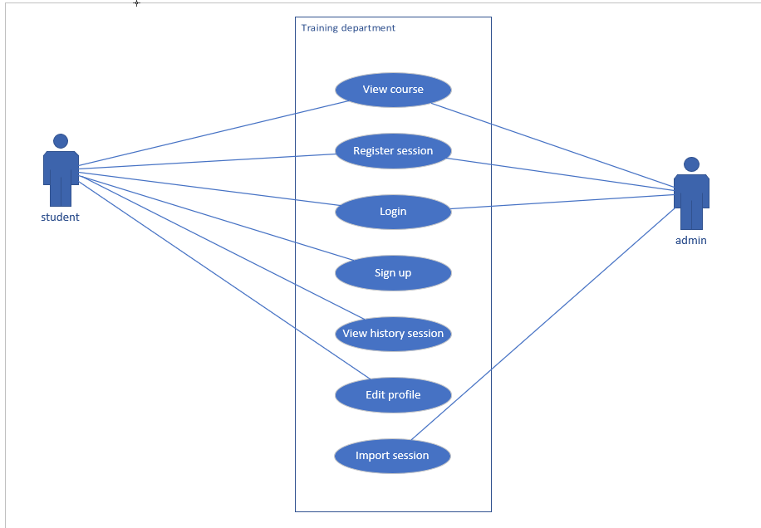

# ERD version 3.0

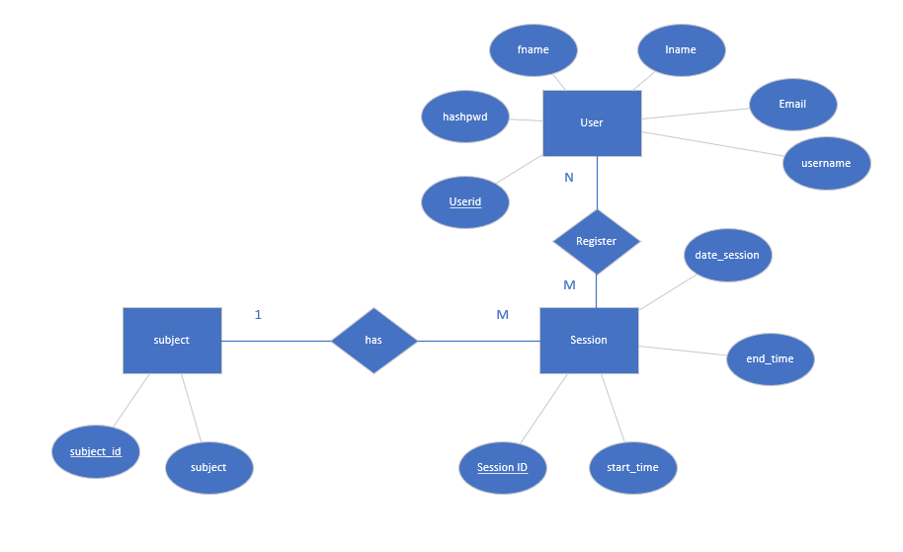

# Flowchart

## User flowchart

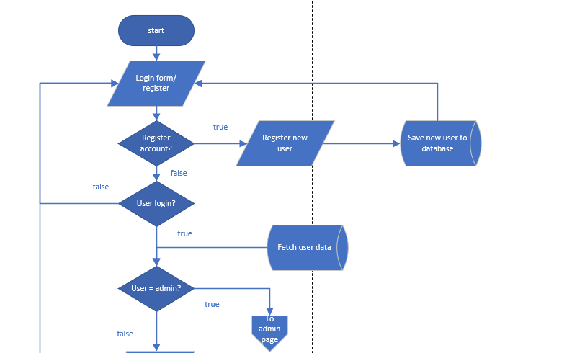

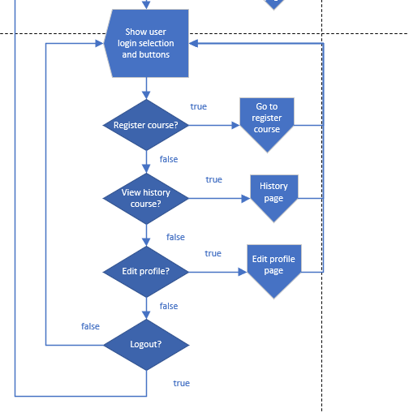

## Register course

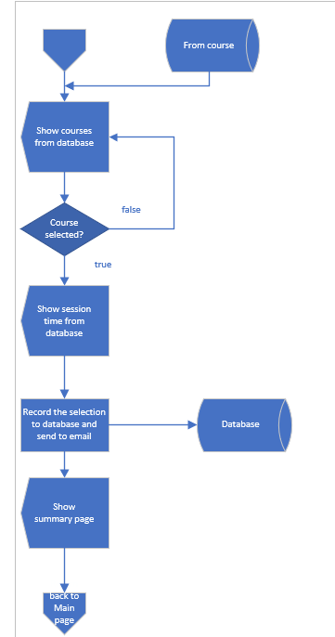

## Check session history flowchart

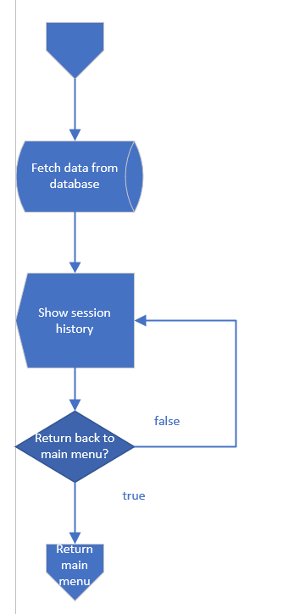

## Profile page

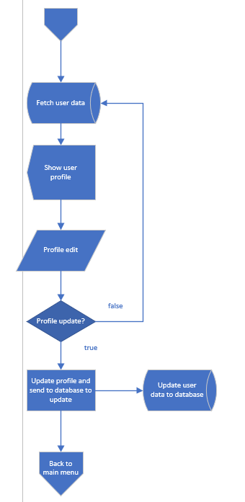

## Admin page

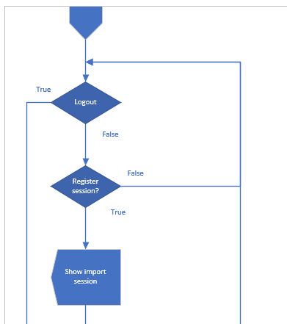

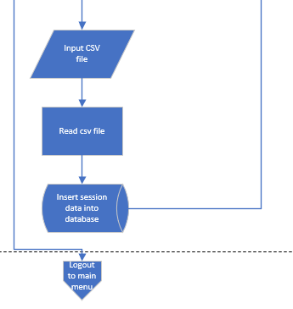

# SQL version 3.0

Database name: tdp_model

## Class_session table



## Users table



## Course table



## Session_record table



## SQL Procedures

### Find_user_record





### This_year_session procedure





### Insert_class_session

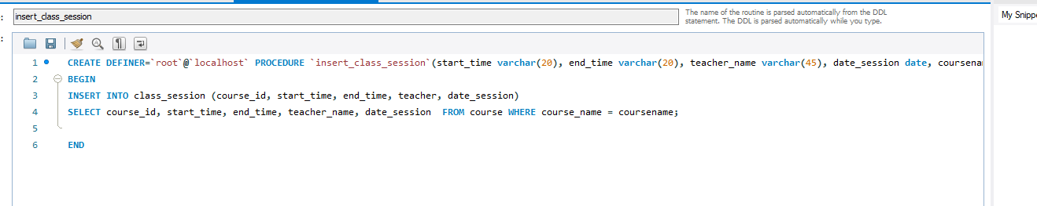

### Check_else_insert_course

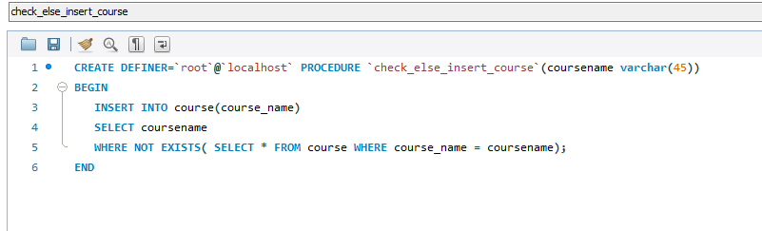

# Webpage interface version 3.0

## Main menu

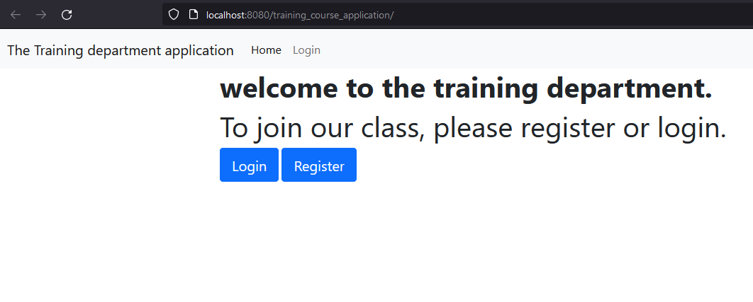

## Login

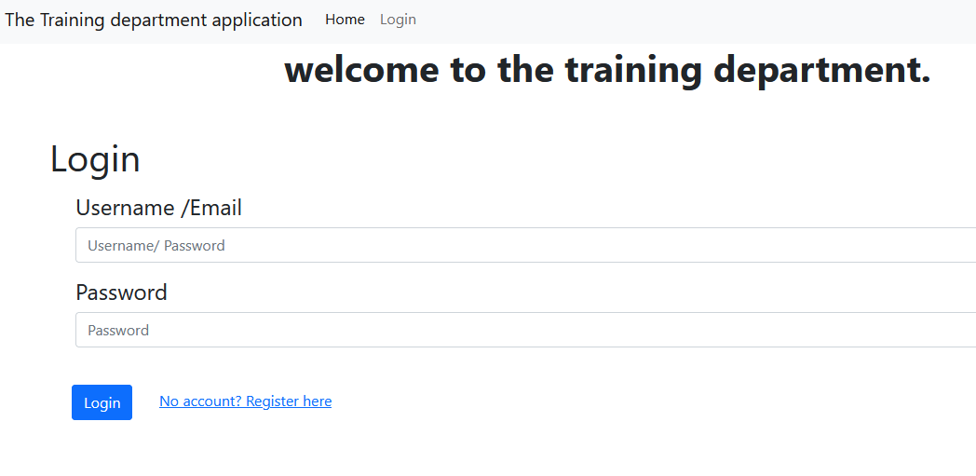

## Register

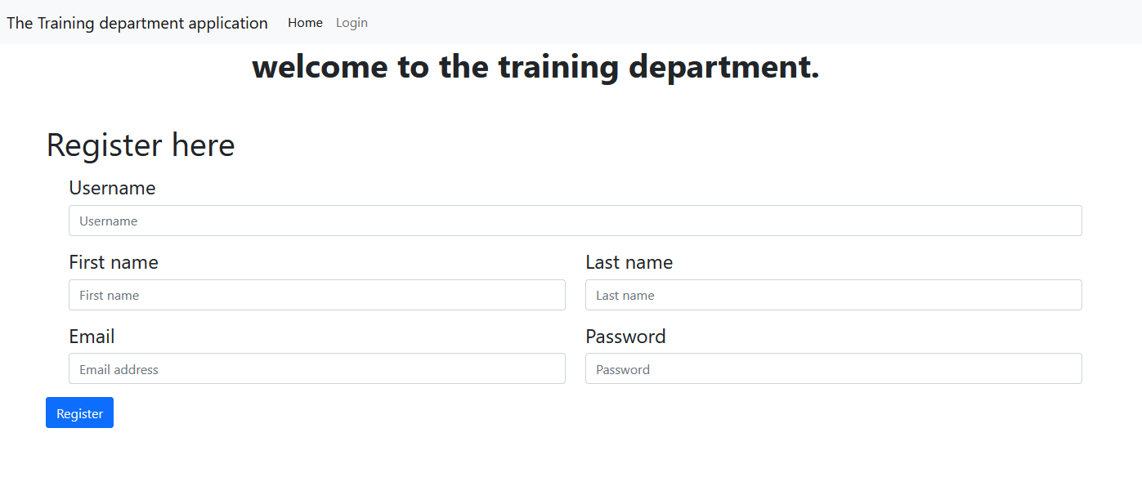

## Main page for user

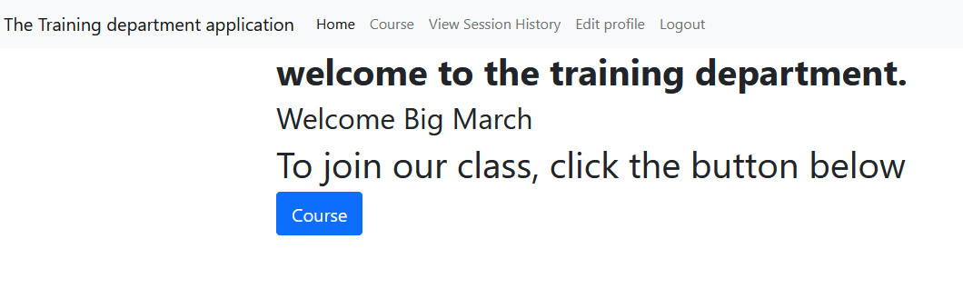

## Main page for admin

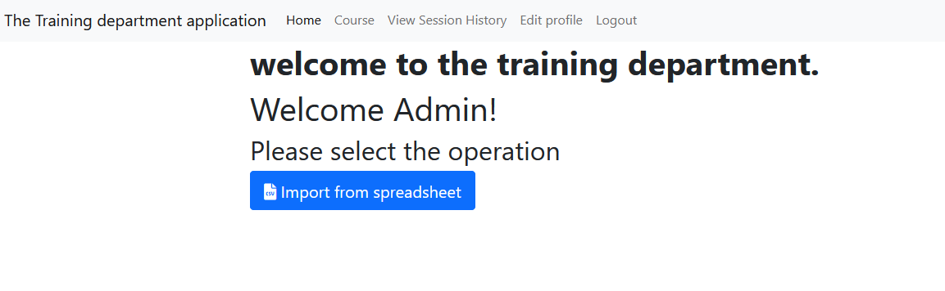

## Admin page import spreadsheet

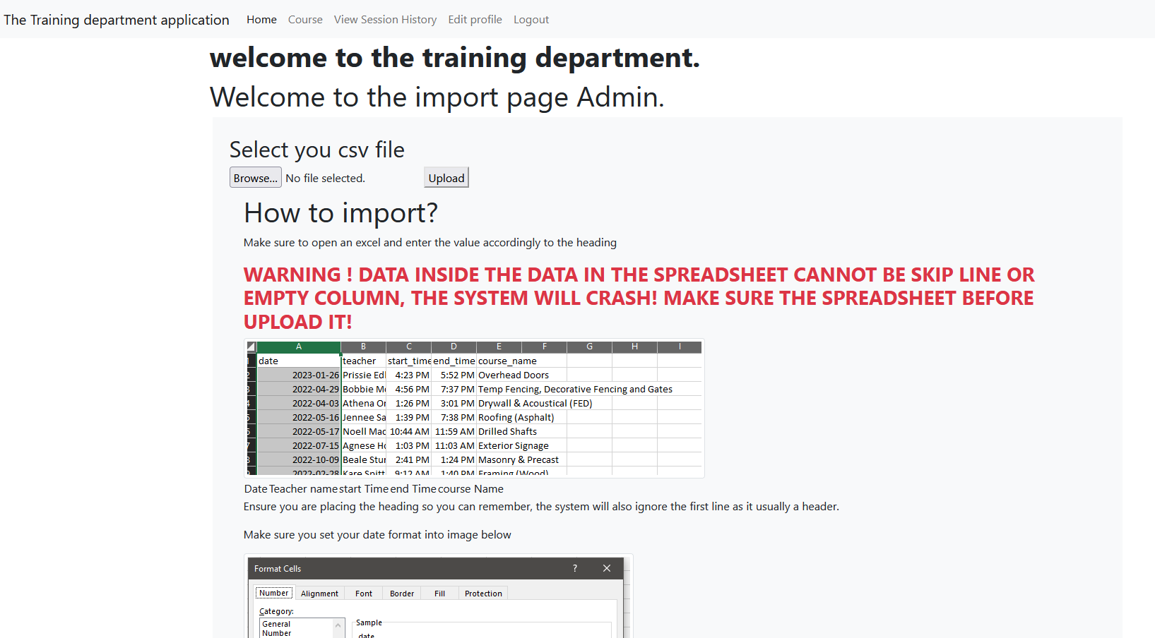

## Import successful page after spreadsheet is uploaded

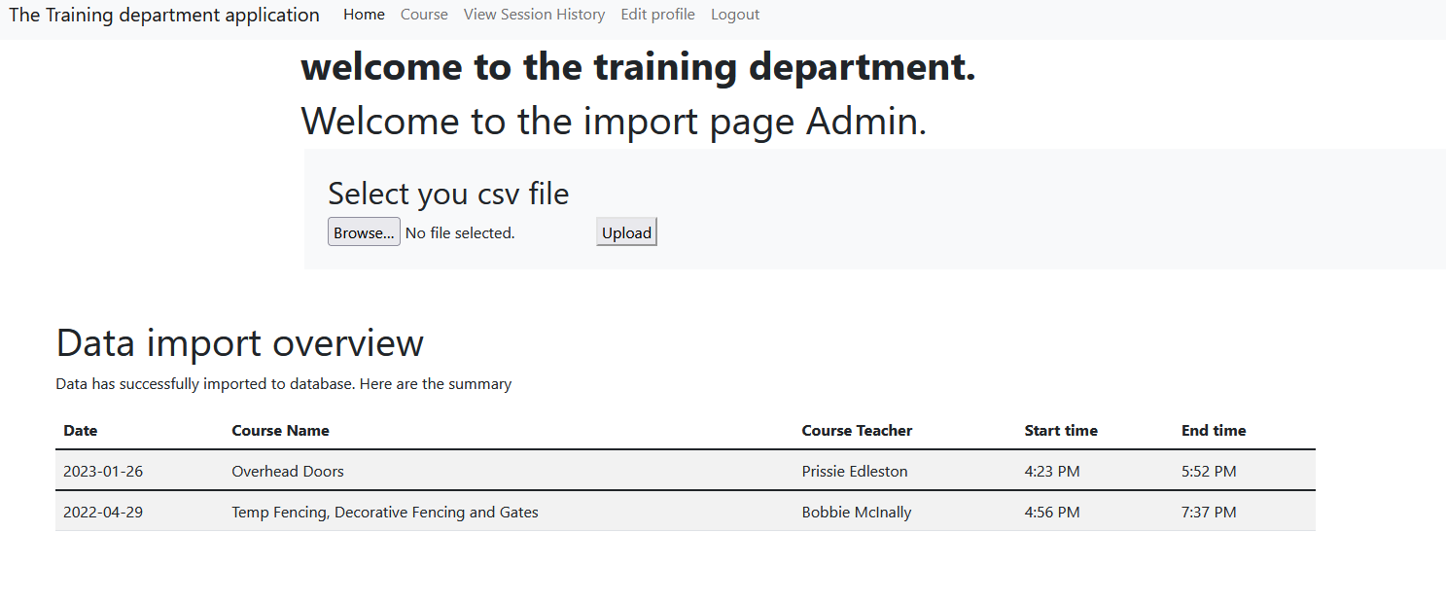

## Wrong file content

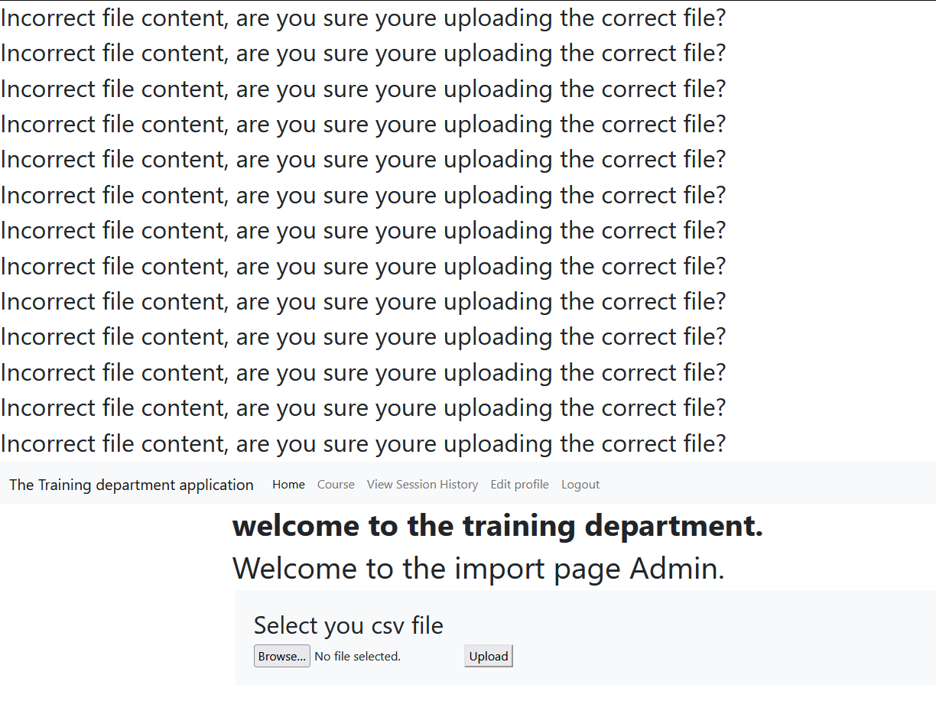

## Course selection page

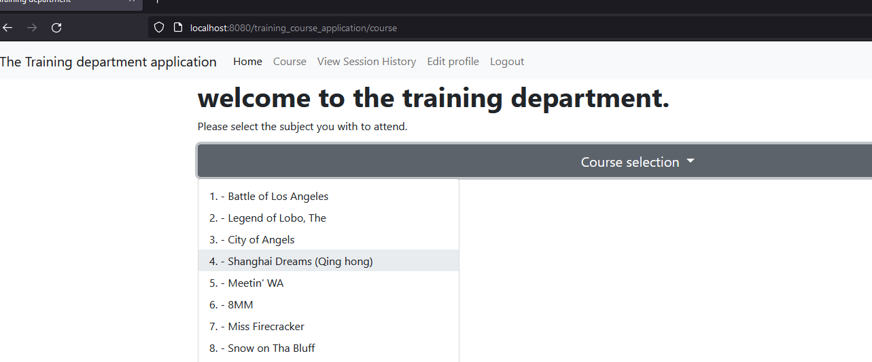

## Select time session page

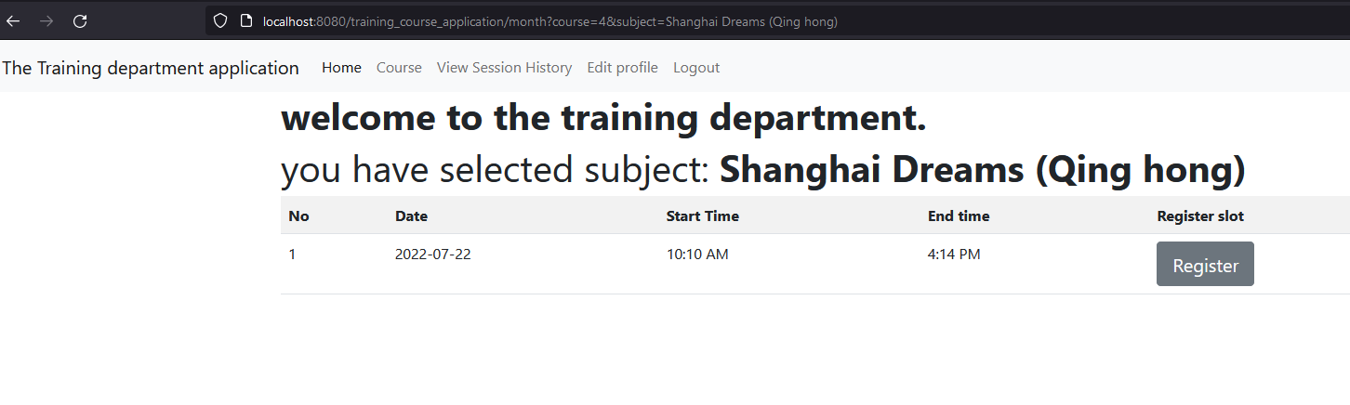

## Summary page

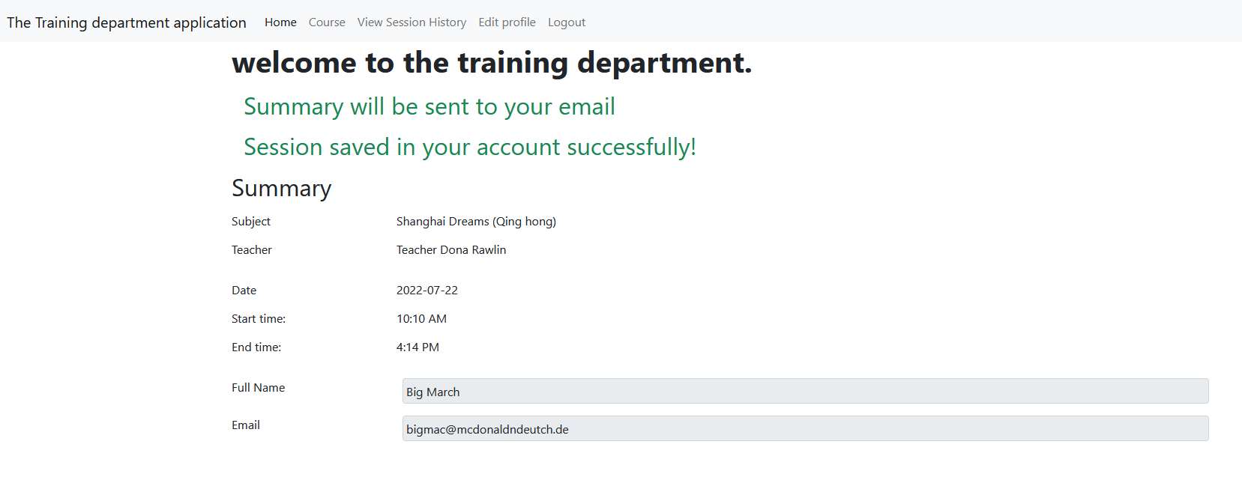

## Email page

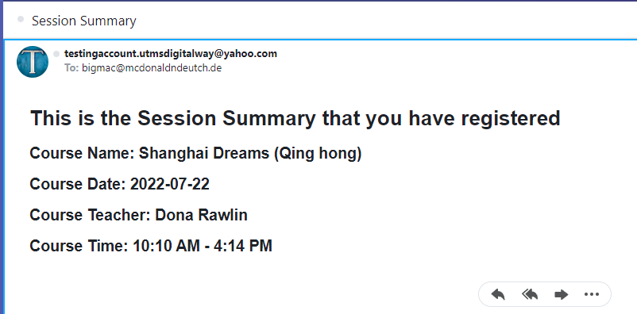

## Session history page

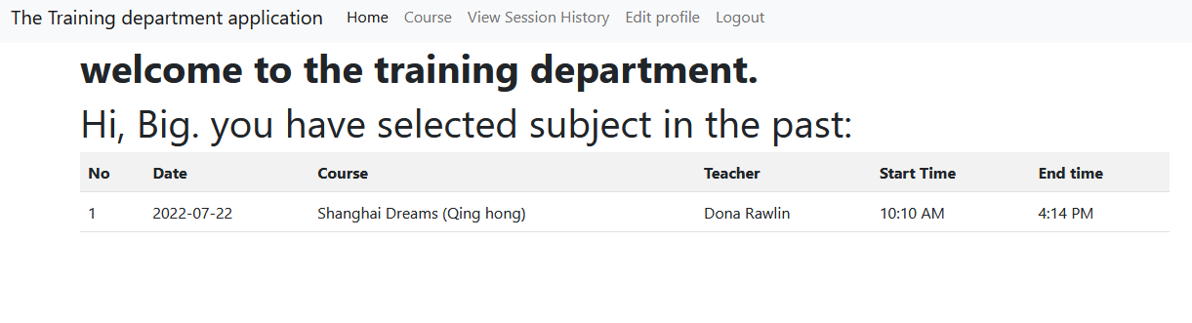

## Edit profile page

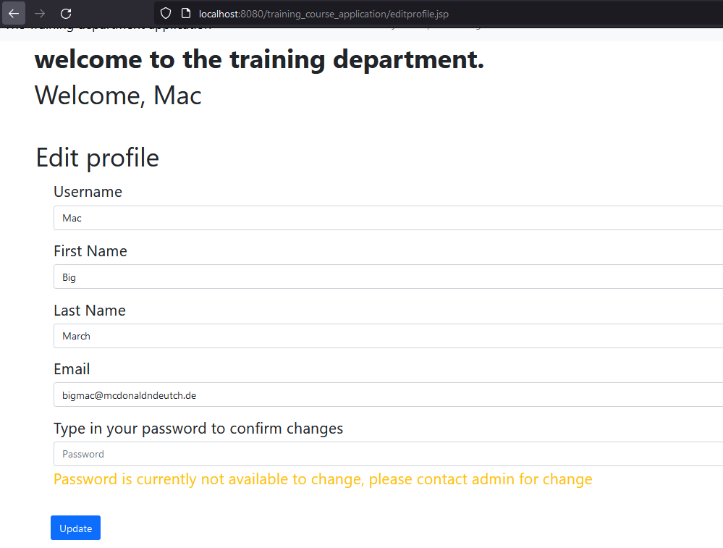

## Change profile

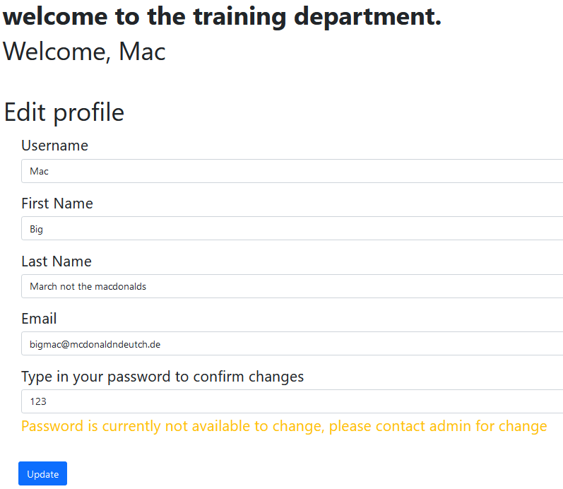

Profile after successfully update

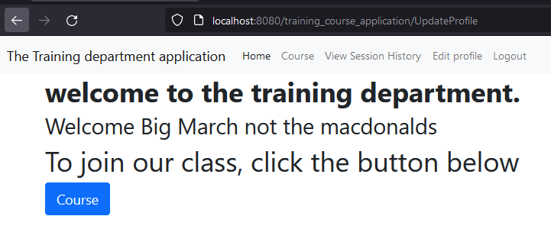

# Source code 3.0

## Heading.jsp

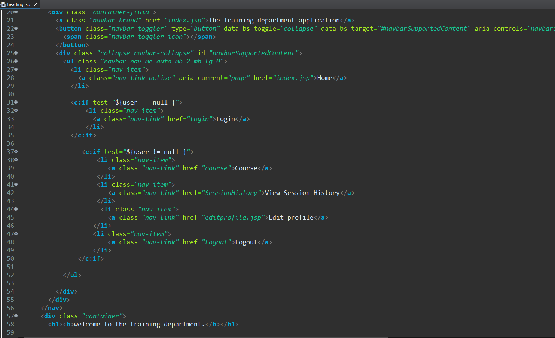

## Index.jsp

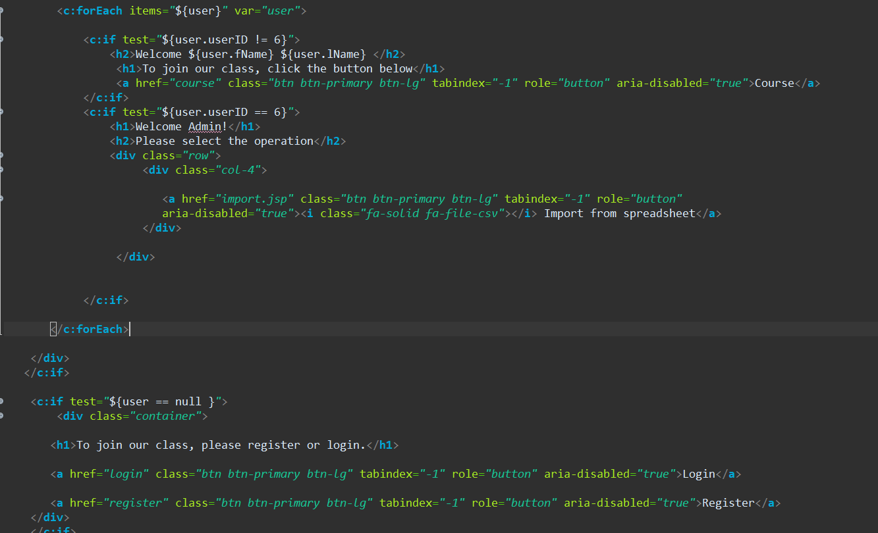

## Login.jsp

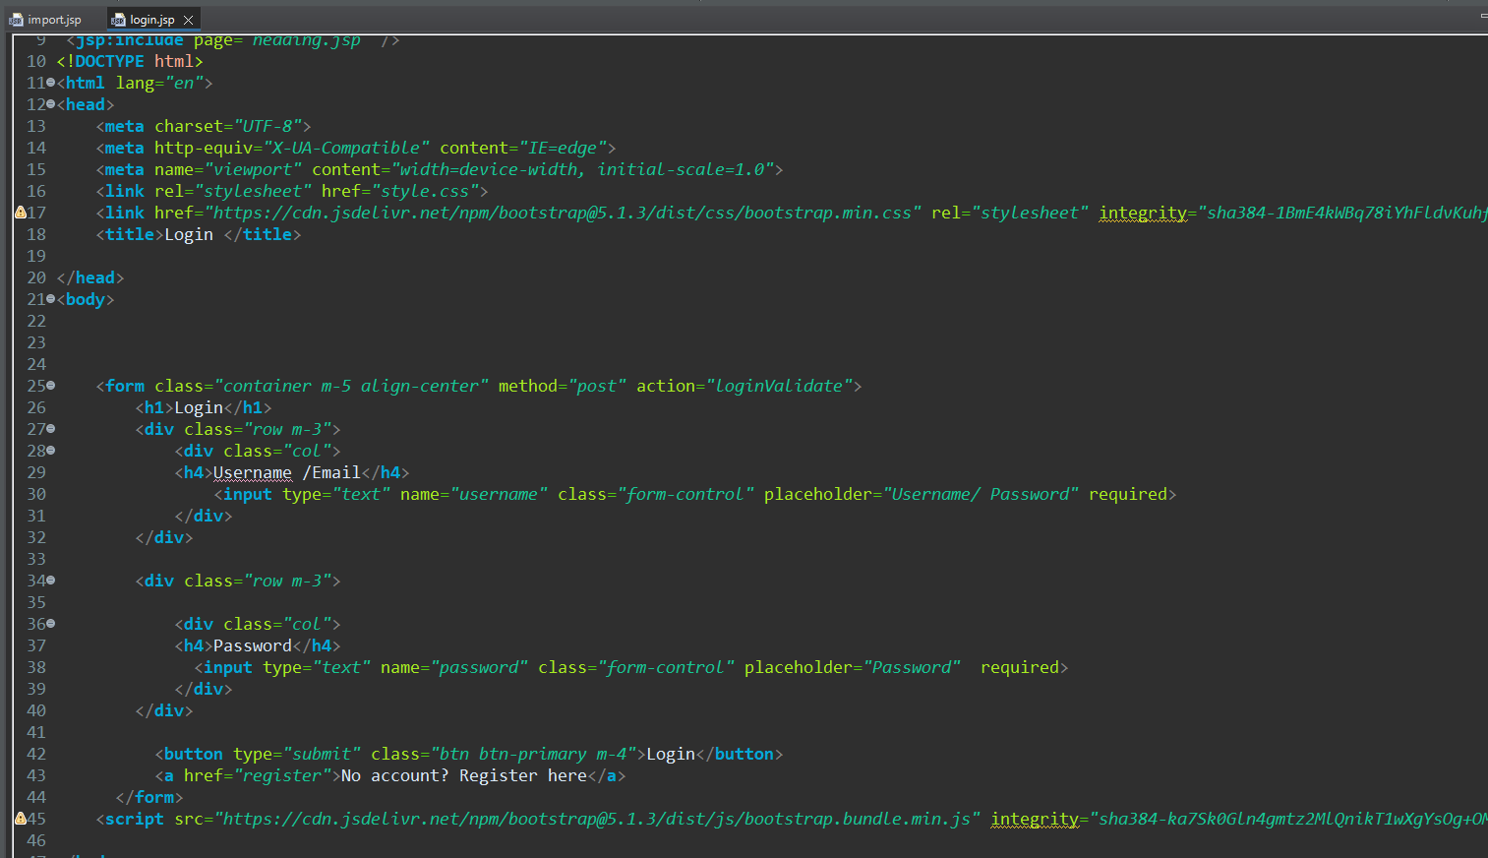

## Register.jsp

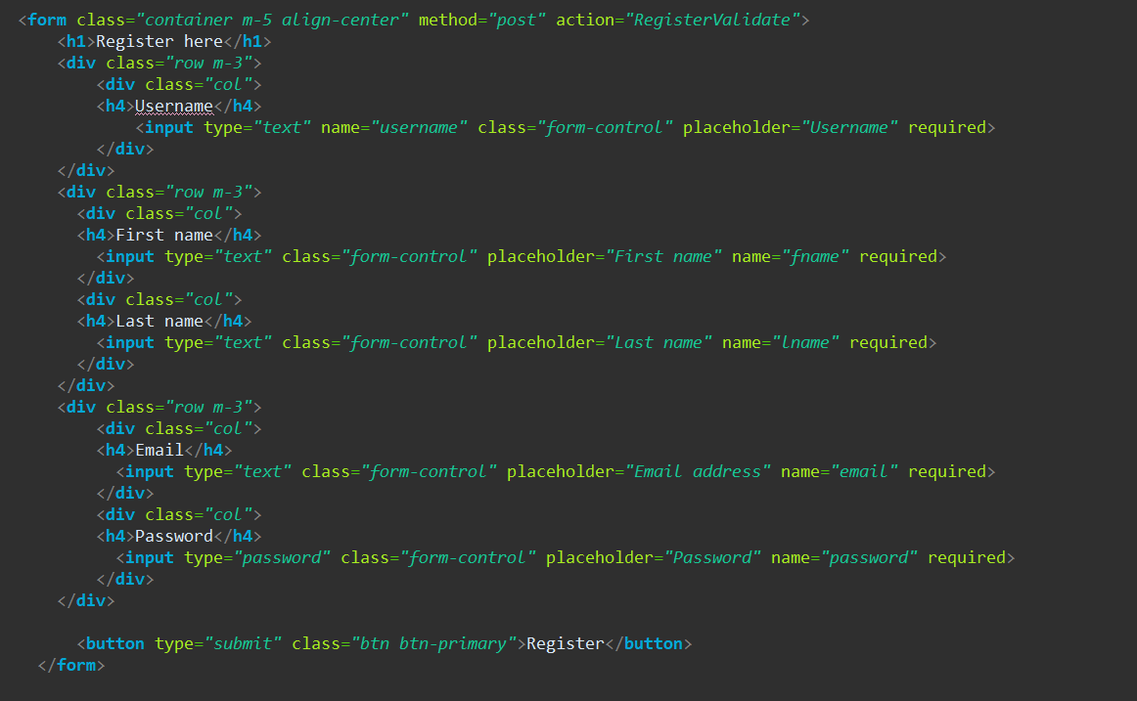

## Import.jsp

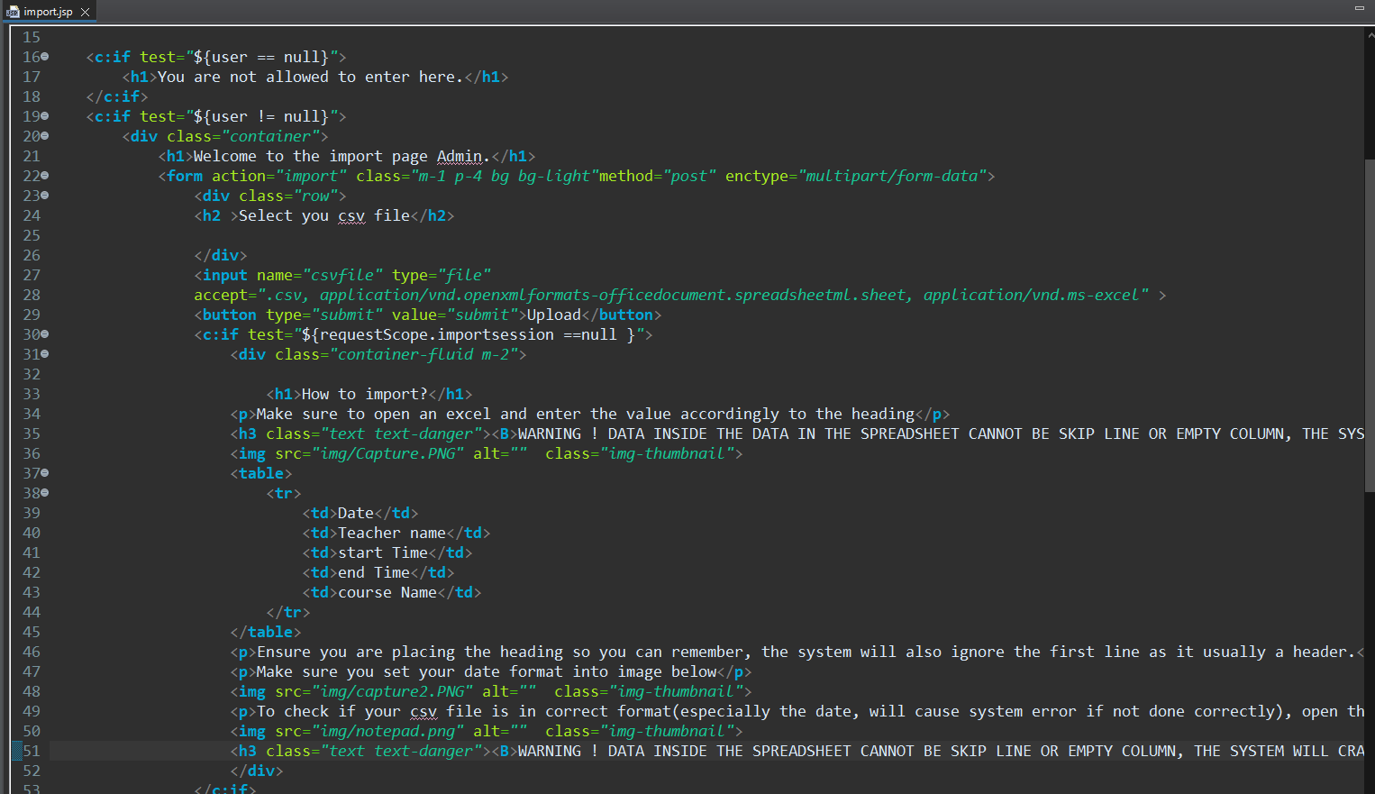

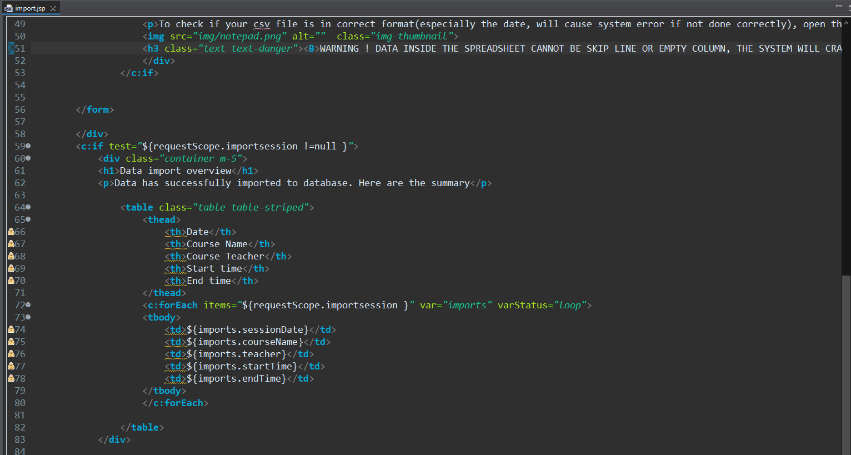

## Form.jsp

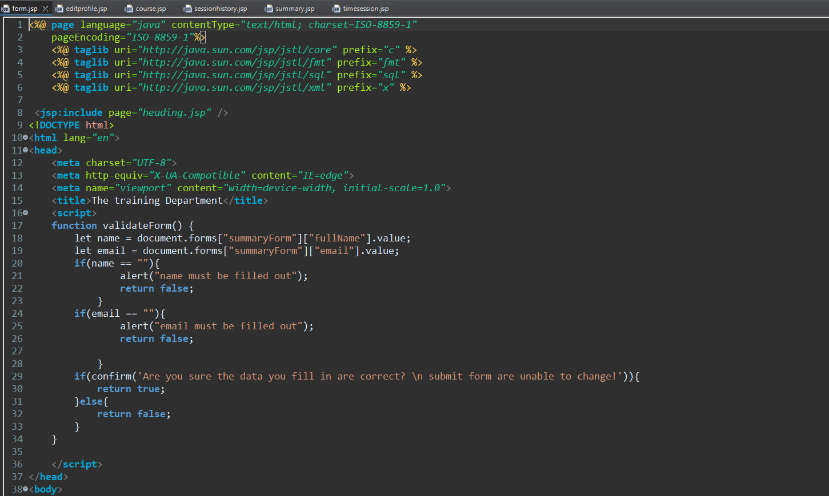

## Editprofile.jsp

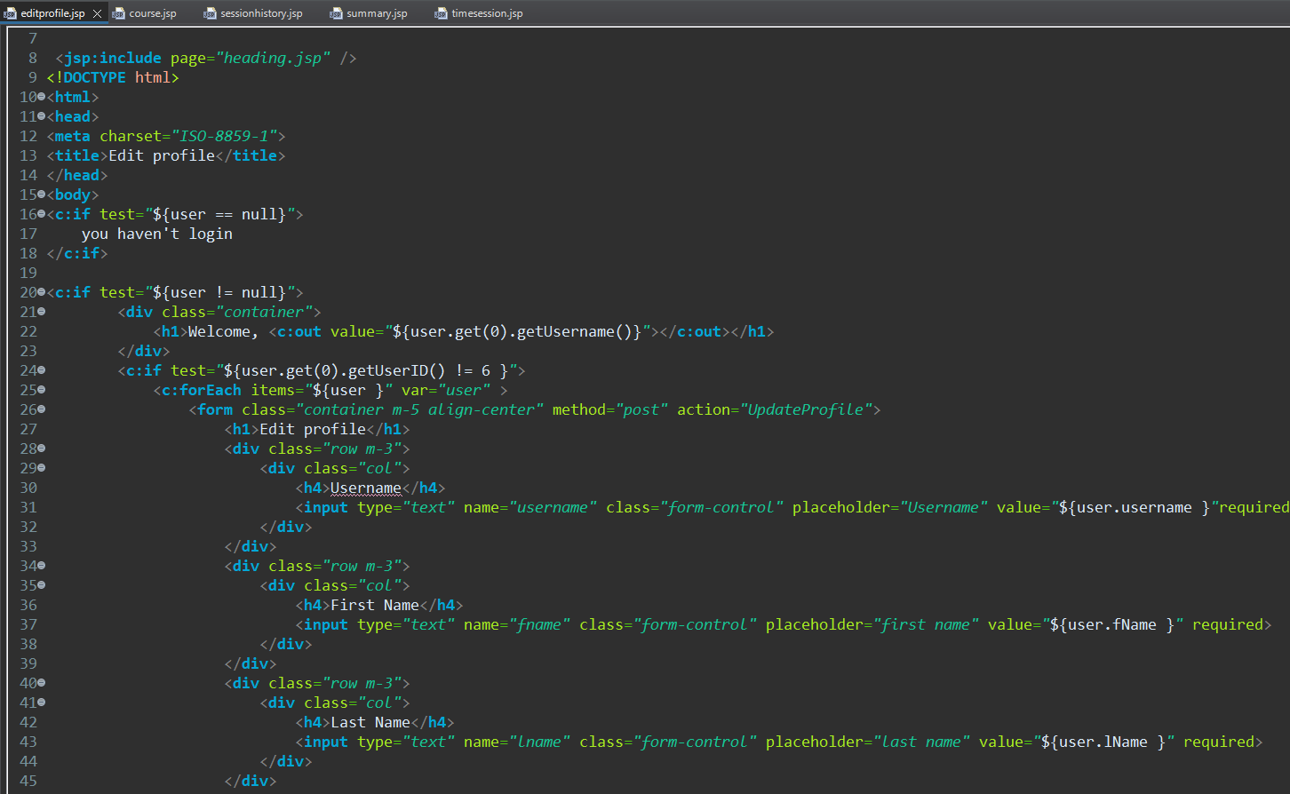

## Timesession.jsp

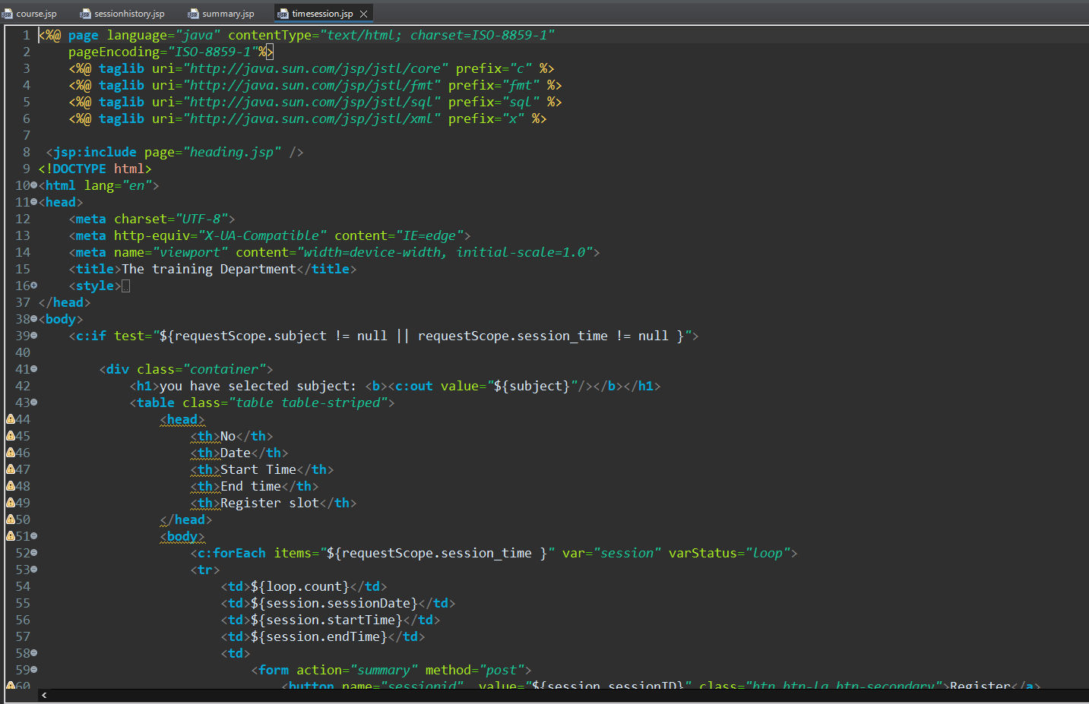

## Summary.jsp

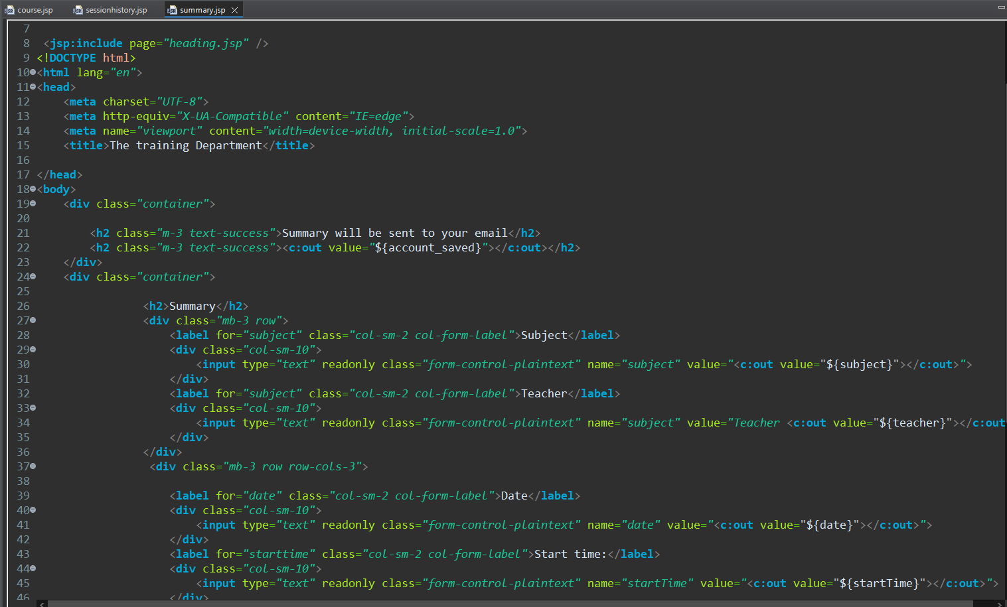

## Sessionhistory.jsp

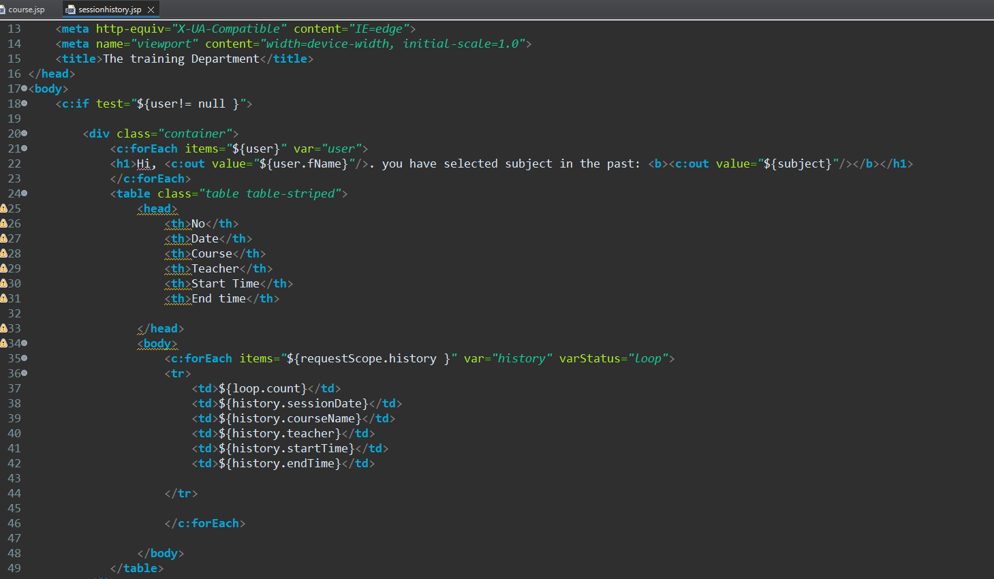

## Course.jsp

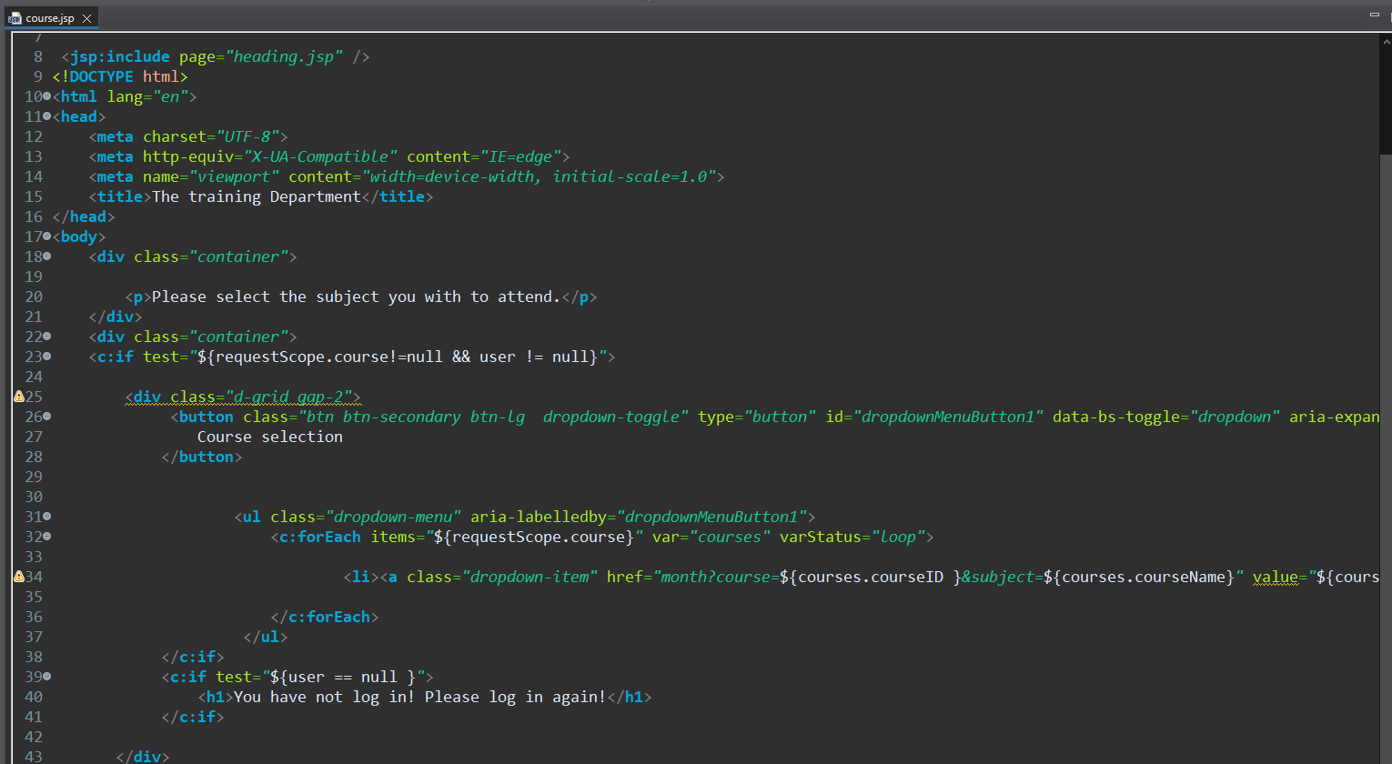

# Library integrated in the system 3.0

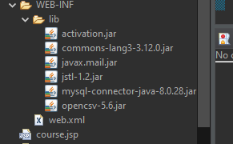

Jstl 1.2.jar

Mysql. JDBC- 8.0.28

Opencsv- 5.6

Javax.mail

Commons-lang3

Activation

# Justify decisions made how the system will result in an effective solution.

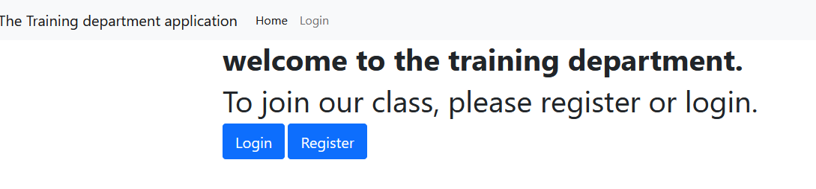

The reason I would like to design a login/register system is I assumed that the company employees have their own emails. Hence, it is better to use this authorization system to track the users name and emails without retyping it if the course they want to join a lot of courses.

I decided to make users to select from **subject first** before selecting the time session is to make sure users that decided to join the **course subject** to register quickly without surfing around the website.

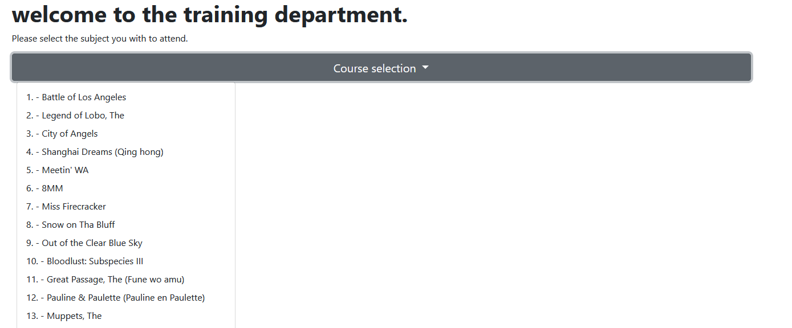

For the selection time session, I make sure the user is **really selected** the course they want. Hence, I show the selected subject in the interface.

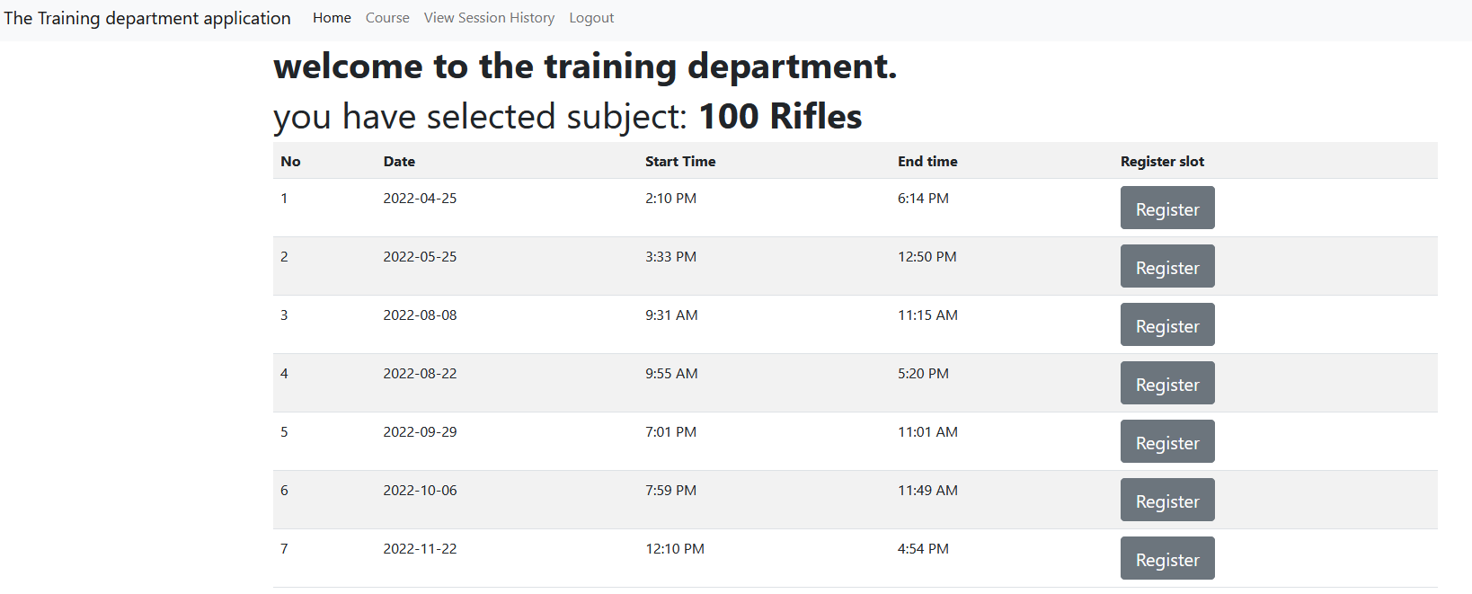

The date is sorted in ascending order so that the user will not be confused by the time showing on the table. I also separate out the start time and the end time to let user to read easily while making their time decision. The register button is made big to allow user to press easily.

For the summary page, page is made to show user the subject they will be choosing, date, time and the summary will be sent the user email. 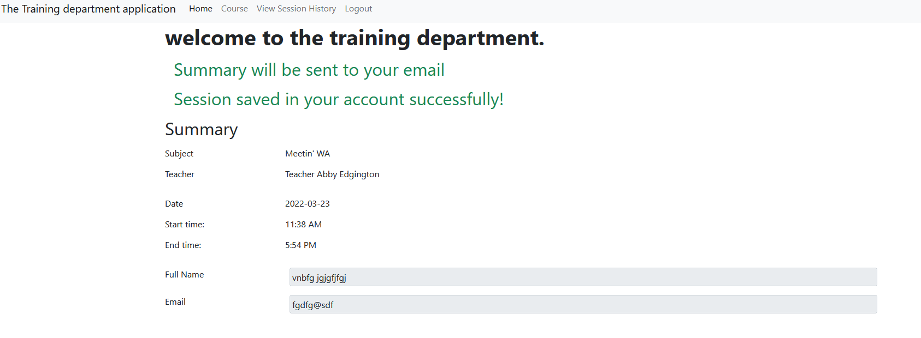

User can use it to double check the course they choose. In the email, the result will show like this:

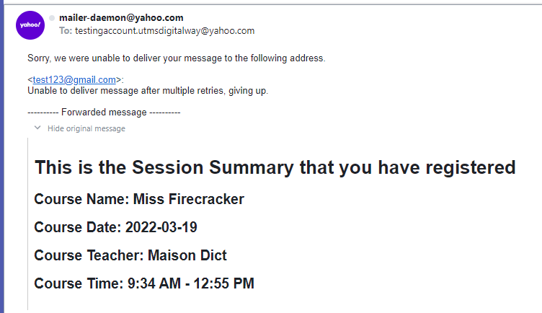

The summary is sent from yahoo email to others

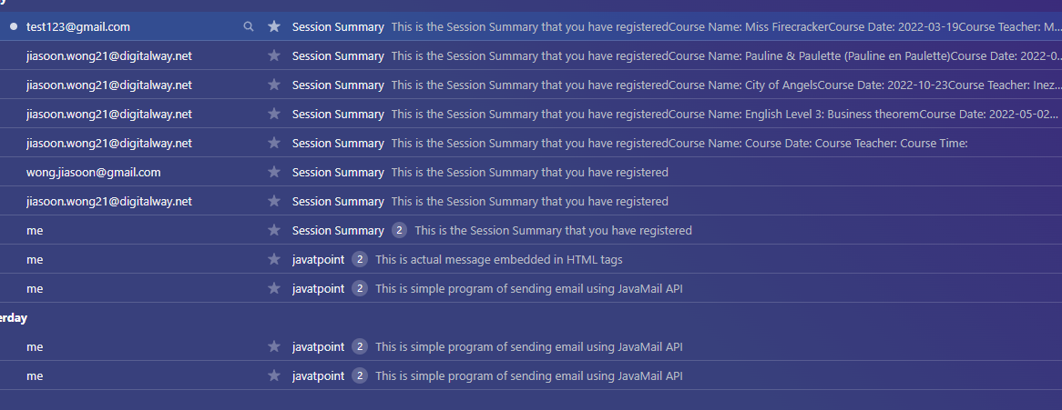

To revisit the summary they picked. User can visit the view session history page.

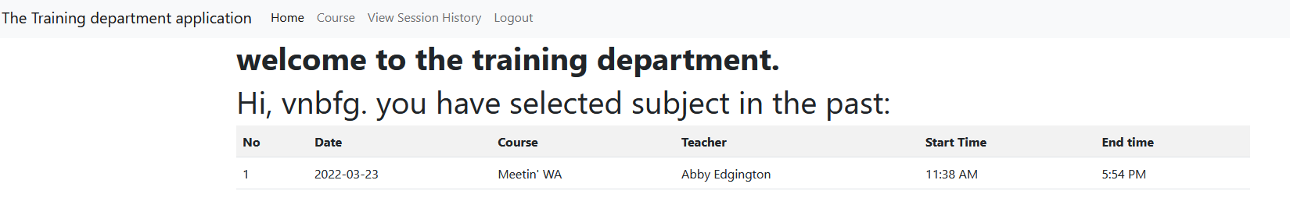

User can also edit their profile.

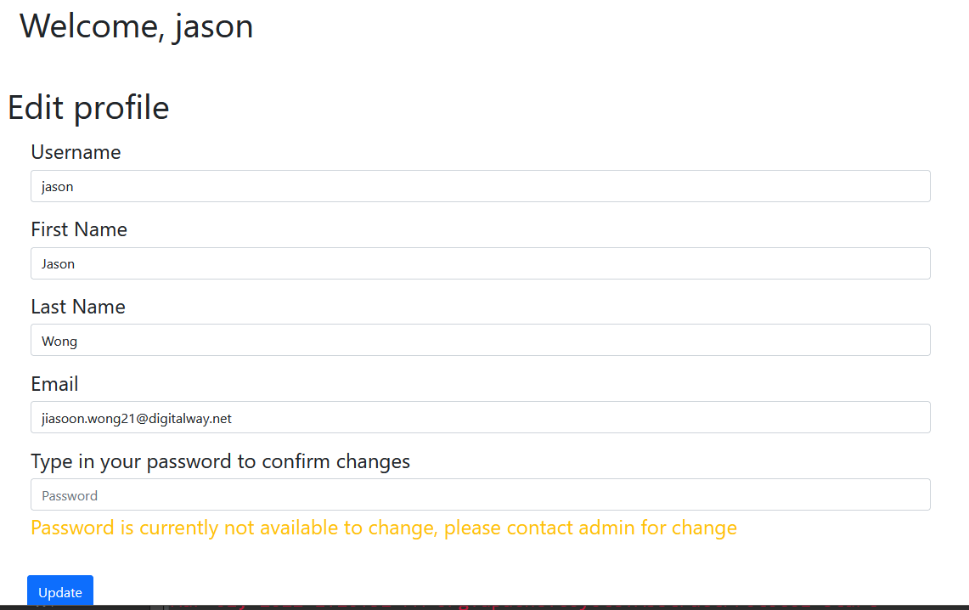

In the admin page, admin can import the csv into the database.

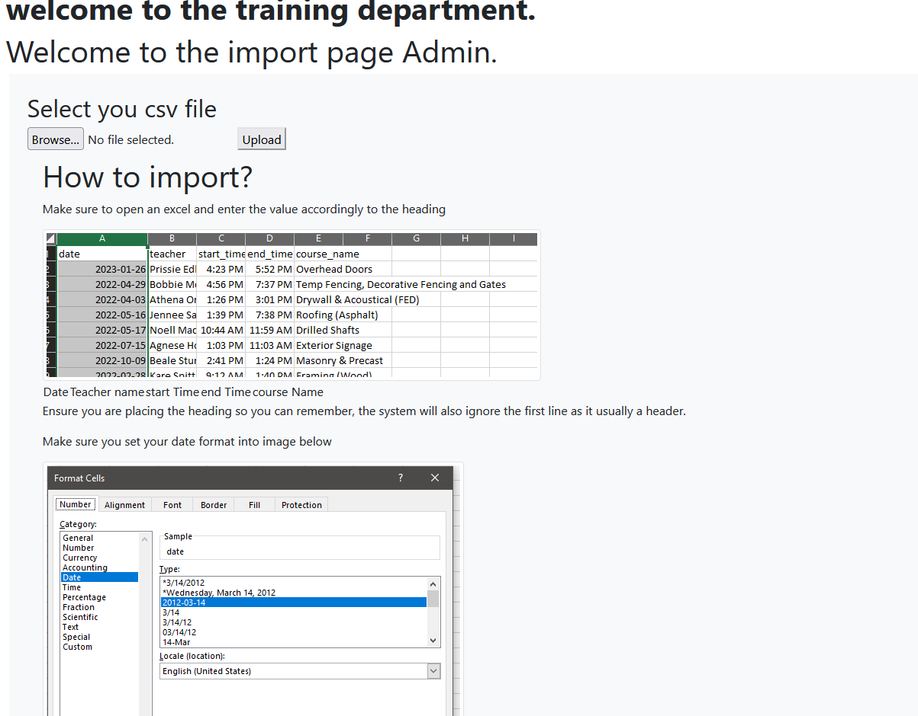

There are also tutorial on how to prepare the spreadsheet file to import to the database

## Future planning for the system

In future design and upgrade I would like to:

* Add admin system
  + Create session
  + Edit session
  + Delete session
* Add edit user profile
  + Add gender, age, department area
* Add class learners quantity to the session time
* Add function to filter the class that is already finish
  + View history session have the option to hide the course that are dismissed or done.
* Add status on the session class for **complete, done, cancelled**
* If possible, add some company update news to the system.